**NEWSLETTER**



*Quarterly Newsletter Published by Haramaya University Research Office* January 2017

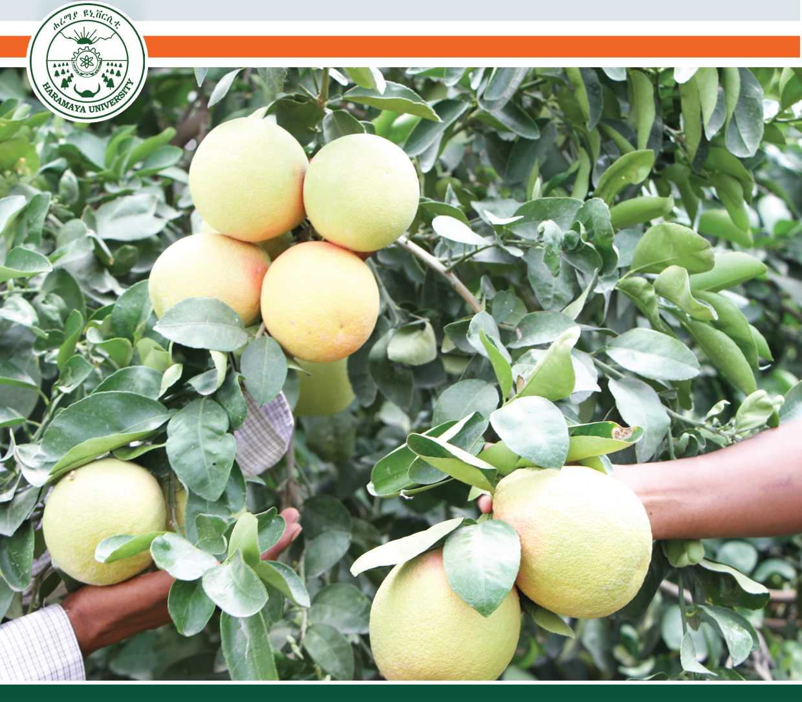

**Composed and Formatted by:**

**Prepared and Edited by:**

Ms Abenezer Estifanos Dr. Nega Assefa Dr. Mengistu Ketema Mr. Admikew Haile Mr. Nigussie Angesa

Ebrahim Seid [ebrahimhu@gmail.com](mailto:ebrahimhu@gmail.com) +251 915 041451 [www.haramaya.edu.et](http://www.haramaya.edu.et)



Cover Photo: Orange fruit taken from Dire Dawa Tony Farm

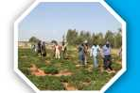

2016 Field Day Completed Successfully

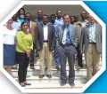

Kersa HDSS In Hopes for New CHAMPS Network Project

Demand Should Dictate Research

Agricultural Experts Receive Training on Transferring New Technologies

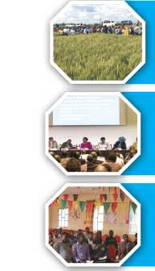

‘Changing Africa by Africans for Africans’: Haramaya University Attends RUFORUM

Kersa HDSS Goes Digital

Serving the Locals

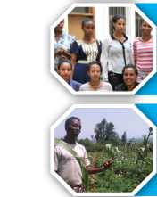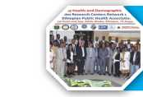

Communication Needed between Research, Policy and Media

University Alerts Possible Wheat Rust Outbreak

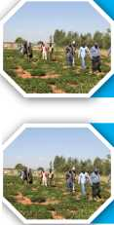

Research Capacity Building for Improving Quality of Theses and Dissertations



*BaHa-zeyit*

**Released in 2016**

**23**

**25**

Haramaya University

Research

Stations

Haramaya University Research Themes and Sub-themes

**27**

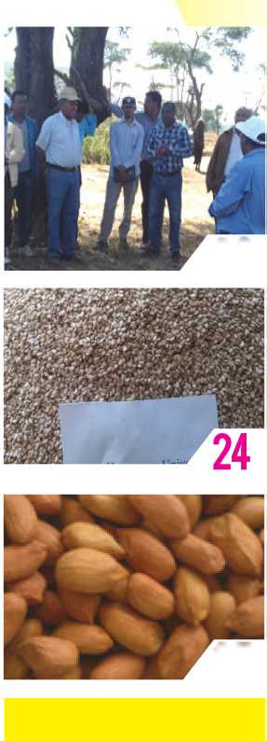

2016 Field Day Completed Successfully

Farmers, researchers, development agents, delegates of re­gional, zonal and woreda offices of agriculture, administrators, and representatives from Haramaya University were present for the 2016 Field Day that was conducted from November 09-11, 2016 at three different districts.

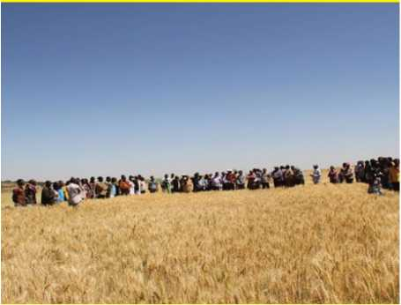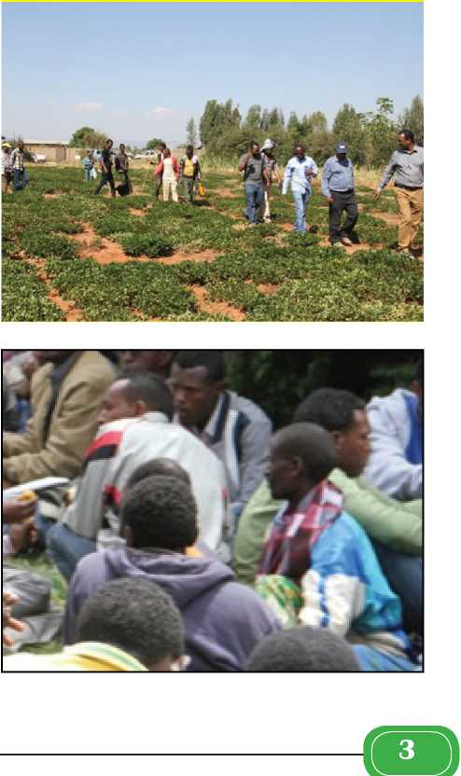

Dr. Jemal Yousuf, Vice-president for Research Affairs, ex­plained that visitations like this would show the progresses of the ongoing farm practices and works that are being done on Farmer Training Centers (FTCs) to strengthen the scholarly contributions and collaborations of farmers, researchers, and development stake­holders. The scheduled three-day trip covered two research sites: Gi- rawa and Babile and two FTCs at Chinaksen.

Day-one of the visit was at Chinaksen and participants ob­served works done on wheat, sorghum, groundnut, sesame, and beans. On Day-two, the team visited Gurawa Research Center and saw the tremendous works the personnel at the Center have done. The Research Center has an impressive site that is filled by crops such as maize, wheat, sorghum, carrot, potato, bean and many more. Babile Research Center, which the team visited on the third day, boasts works done on groundnut, sesame, sorghum, and other crops. The Research Center serves as the home base for the University’s Na­tional Groundnut Center of Excellence.

After the farm visits, a discussion session was held with rep­resentatives from the local farmers and stakeholders at all the three areas in their respective districts. The efforts and achievements of the University, gaps to be addressed, and the way forward were raised and discussed. Farmers raised their problems and worries during the discussion including as to how they may get hybrid seeds sus­tainably, obtain sufficient market opportunity for their produce, and exposure to new technology. Concerned officials gave explanations and briefings to the raised questions.

Finally, Dr. Jemal said farmers should be encouraged and supported to use improved technologies to enhance food produc­tion; such joint discussions should be made habits to follow for the future to design and do fruitful research in a participatory approach and he thanked all the field day participants and wished them safe journey back home.



Kersa HDSS in Hopes for New CHAMPS Network Project

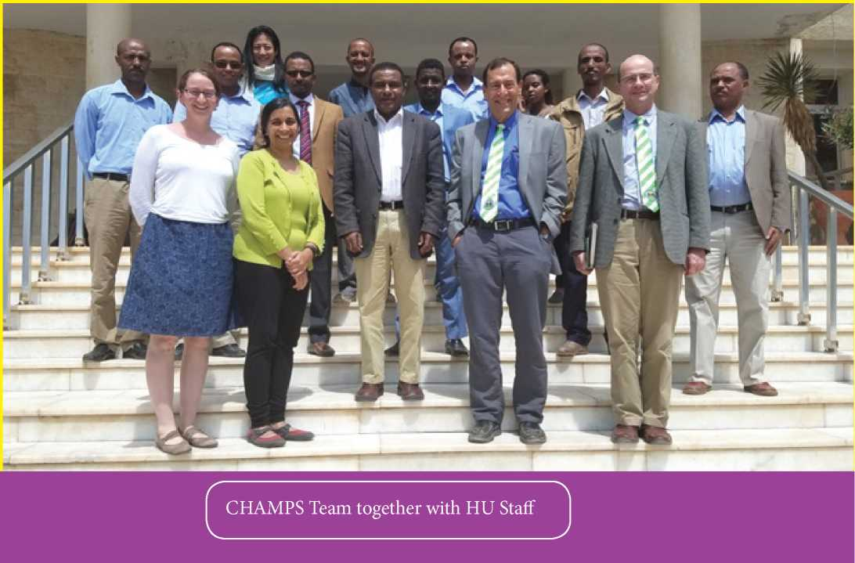

Child Health and Mortality Prevention Surveil­lance (CHAMPS) Network team met with Haramaya University’s President, Vice-President and Directors on 3rd Nov. 2016 to discuss the new project that works on the tracking and prevention of child health and mortality. The project so far has selected six sites in the world with high mortality rate of children under-5 and would work on identifying main areas of focus, tracking child mortali­ty and mortality prevention. Kersa/Harar HDSS including Hiwot Fana Referral Hospital is among the six sites. The main idea of the Network is to share collected pathologydata from the different sites, hopefully in real-time, with the Central Storage Facility using telepathology to analyze, share and notify the different stakeholders of the result. The specimens are expected to be stored in local storage facilities; some would be sent to the Central Storage Fa­cility at the Center for Disease Control and Prevention (CDC). After the data are analyzed, the panel members such as family members and clinicians who have been tak­ing care of the child or children would be notified of the cause of death.

In the discussion session held at the President’s Office, questions were raised and the team gave their feed­back. one raised concern was the integration and linkage of the project with the learning-teaching process in the University. The team pointed out that the project is a ‘ro­bust project’ with a multidisciplinary dimension, from which thesis and dissertation topics would be generated. New techniques in the labs would also serve as opportuni­ties for students to learn and be involved in; one major and obvious benefit for students would be the sequence diag­nostics that is expected to be implemented in this project.

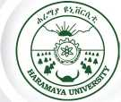

> Quarterly Newsletter

Issue 2 and 3, January 2017

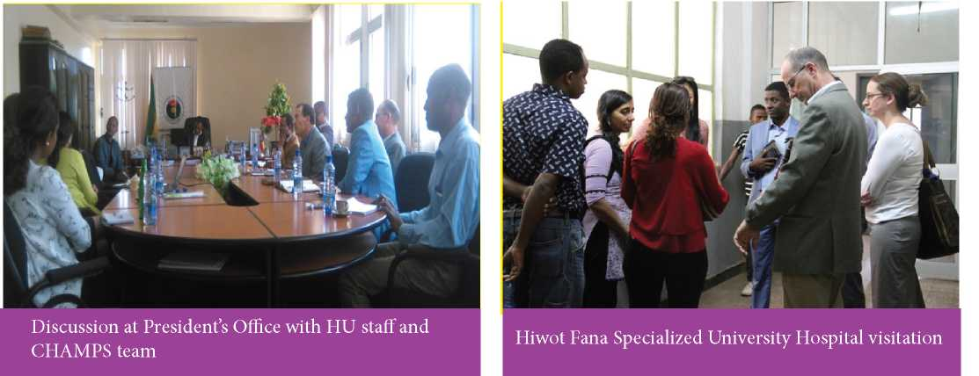

An added feature to this project is its inclination to work with social and behavioral scientists. The behavioral science personnel would help in getting to the communi­ty members to talk to, to inform, to teach and to create awareness, in general, to test the waters, so that CHAMPS would be able to come in and do the scientific part. As every community has its own experiences, understanding the community and designing and adapting tailored inter­vention and prevention procedures that reflect and do not offend/anger the community is crucial.

The CHAMPS Network is being funded by the Bill & Melinda Gates Foundation and has a goal to achieve a much reduced child mortality rate by 2030. For this par­ticular project the Foundation looked for countries and sites that need support in their works on child mortality. As many countries in Africa have an already established international foundation, organization and/or institution, the Foundation looked for an institution or site that has either a strong HDS site or clinic or microbiology labora­tories. Kersa HDSS was selected for its strong and well-es­tablished work in tracking and documentation of child mortality for children under-5. Having a CHAMPS site would also open up the doors for further funding from national and international institutions. It has been iden­tified that this project could put Haramaya University on the map in the child mortality prevention works and could also help the University to become a Center of Excellence not only in the Eastern part of the country or even Ethi­opia, but also internationally. Here, a very good example mentioned by the CHAMPS team was the experience in Kenya where a village that started out as a small DSS site became the largest DSS site in the country and has more than 100 scientists and a number of post graduate students based in it.

The CHAMPS team also visited the pediatric wing of Hiwot Fana Specialized University Hospital and its lab­oratories, and the Kersa Health and Demographic Surveil­lance System (HDSS) site to fully grasp what the University has and works on, and to identify the gaps and shortage of lab equipment, trained personnel and the overall perfor­mance of the University on child morbidity and mortality prevention.

Haramaya University Research Office conducted Field Day in the University’s compound on 13 October 2016. This year’s Field Day was attended by mass of stake­holders that include farmers, researchers, development Agents (DAs), delegates of regional, zonal and woreda of­fices of agriculture, agencies of livestock and fisheries de­velopment and administrators and academic and admin­istrative staff members of the University.

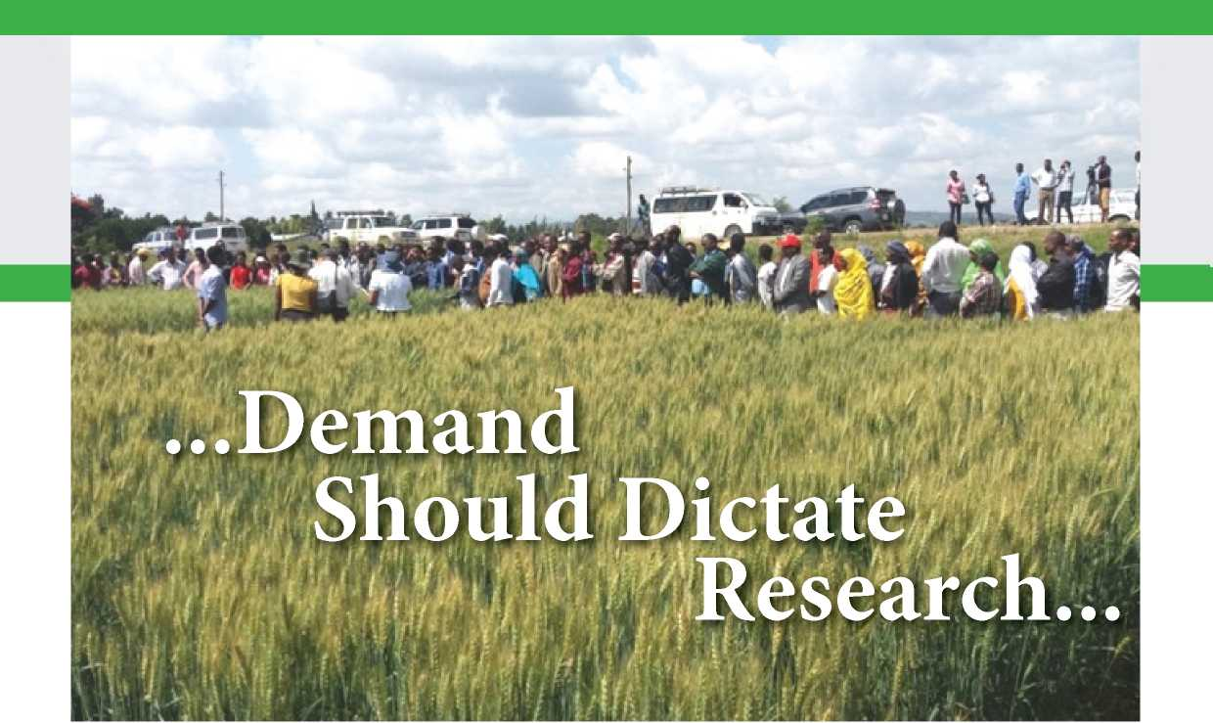

The guests were given a tour of the research fields and farms of the University and introductions and expla­nations were given on what kind of activities the University has executed. The Field Day mainly involved demonstrat­ing portions of the works that are being conducted in the University and showing the possible potential of linkages at different levels with as many stakeholders as possible.

A welcoming speech was given by Dr. Jemal You­suf, Vice-President for Research Affairs; and an open­ing speech by Prof. Chemeda Fininsa, the University’s President. The President, in his opening speech, talked about the relevance of research field day and advised, “It shouldn’t only be a scheduled event that we do year af­ter year. Research field days should have something new and special to be shown every time they’re held.” Prof. Chemeda stressed the idea that new discoveries should be demonstrated so that farmers and stakeholders know the University is committed to addressing problems of our so­ciety.

Prof. Chemeda further noted that Field Days are good opportunities to evaluate the effectiveness of new technologies before they are disseminated to the public.

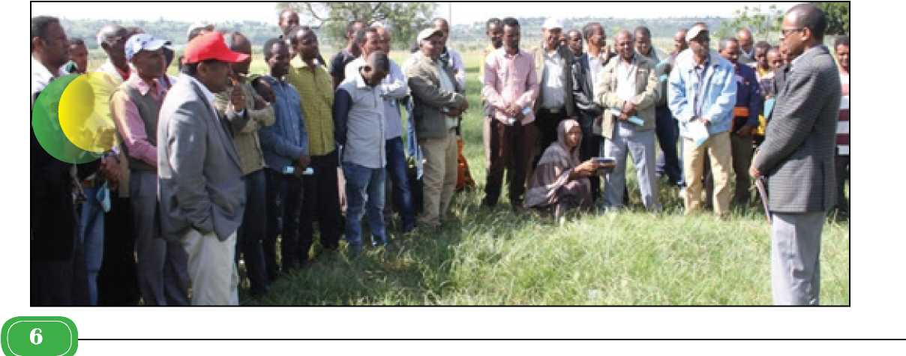

Field days are also helpful in demonstrating technologies in FTCs and disseminating the effective ones for scaling up. As Prof. Chemeda said, “Through research, everything that has been on paper will be tested. The University is not only limited to agricultural research. We have researches in health, natural science and technology, business and economics, and information technology. This (Field Day) only shows the portion that can be seen on the ground.” In a similar note, researchers are encouraged to conduct researches that are geared toward solving our economic, social and environmental problems.

Following the President’s speech, participants were given the chance to make a guided visit of manyit can with the capacity that it has. Dr. Jemal and the Uni­versity’s researchers attempted to address the issues raised by the participants in a satisfactory way. Towards the end of the discussion, Dr. Mengistu, Director for the Research Extension and Publications Directorate, pointed out that regional administrations, woredas’ and kebeles’ agricul­ture, fishery and livestock offices have the responsibility of creating linkages with the University to address the many issues of the area. He said, “It is not only the responsibility of Haramaya University; it is every stakeholders’ responsi­bility.” It was pointed out that farmers should not only be expectants but collaborators in bettering their situations and economic status.

It has also been mentioned that even though it is not in a

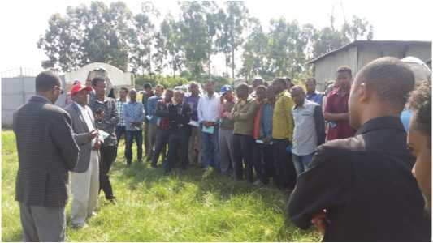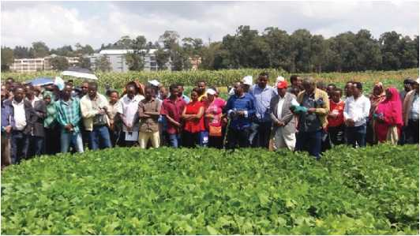

of the research activities that the University is undertak­ing on campus (Rare Research Station). The visit started with the sheep research station followed by beef research as components of the livestock research efforts. Then, the crop research visitation followed in the order of cereals re­search specifically on wheat, highland pulse research pro­gram like faba bean research, lowland research programs like common bean research, potato seed multiplication ac­tivity, vermicomposting technology, sorghum, maize, po­tato, shallot researches, and sprinkler and drip irrigation technologies.

In the discussion session held in the afternoon, the guests raised issues of bridging the skill gap of farmers in dairy housekeeping, poultry, and beekeeping; the lack of reachability of livestock research; expanding fenugreek research; and the reach of the University’s research sphere. Women were encouraged to participate in the discussion, and raised the continuity of the University’s support in addressing the need of poor women in areas of chicken and goat rearing. The discussion was chaired by Dr. Jemal Yusouf, and university representatives gave feedbacks on the raised issues and stressed the University is doing what

grand scale, researchers are conducting research on fen­ugreek (“Abish” in Amharic and “Hulbata” in Afan Oro- mo), and will disseminate the results in the near future. Another point raised by farmers was the scale of livestock research; representatives from HU said this is not to say there is lack of research rather it take years to produce and disseminate livestock research results; it is not as “easy” as crop production and dissemination. But the University has planned to do better in this regard and will collaborate with farmers and the regional administration. Concerning trainings, it was stated that the University has been giving trainings to DAs, selected farmers and extension workers. These will also continue to the capacity of the University.In response to the women’s request, it was noted that the Uni­versity, in its current year’s plan, has an intention to work with needy women on small-scale poultry production in­cluding poultry feed production which is often among the challenges to sustain poultry business.



‘Changing Africa by Africans for Africans’: Haramaya University Attends RUFORUM Conference in South Africa

The continent-wide universities network, RU­FORUM, held its 5th Biennial Conference in Cape Town, South Africa from 17th-21st October 2016. The confer­ence took place at Century City Conference Center, and it was organized in collaborations between Agricultural Research Council (ARC) of South Africa and Center for Coordinating Agricultural Research in Southern Africa (CCARDESA). The overall theme of the conference was ‘Linking Agricultural Universities with Civil Society, the Private Sector, Governments and other Stakeholders in support for Agricultural Development in Africa”. As a member of the RUFORUM Network, Haramaya Universi­ty was represented by its delegates, deans, HU’s vice-pres­ident for Research Affairs, ACE deputy leaders, Graduateer to share knowledge, experience and expertise in var­ious agricultural fields and extension works. Chairper­son of the African Union Her Excellency Dr. Nkosazana Dlamimi-Zuma, Distinguished Lady President of Mauri­tius, Her Excellency Ameenah Gurib, Heads of State from Africa and abroad, chairpersons of various committees and organizations, university presidents and deans, large and small company owners, students, researchers and ex­hibitors were in attendance.

The conference made it possible to communicate and create linkage between major players in African ag­riculture. Learning institutions, agricultural communities and the private sector are all needed to empower and ex­tend the knowledge and expertise to agricultural societies,

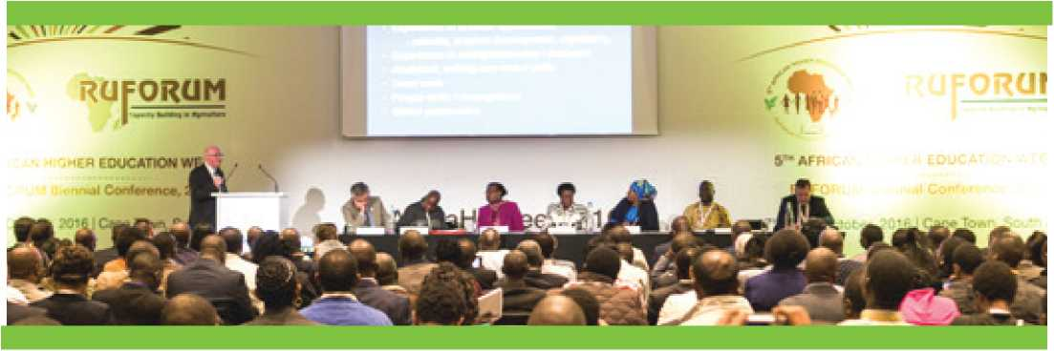

Research Grant Pis, and graduate students attended the conference. The University was also represented in an exhibition that displayed the research and collaboration works it has undertaken, and has been involved in. One of the graduate students, Ms. Selam Kassahuns, research was featured as part of a video showing the best research experiences funded by RUFORUM.

The event brought African Universities togeth-smallholder farmers and boost the African agriculture. Academic leaders of more than 40 institutions, vice-chan­cellors and undergraduate and postgraduate students gathered at Stellenbosch University to visit the campus and attend the series of meetings and talks across campus. Alongside the meetings and talks held at the conference center, exhibition booths were arranged for universities and other stakeholders to exhibit their works.

The week’s activities ended on a high note with standout academic and entrepreneurial achievements be­ing officially recognized. Young African Entrepreneurs Award was presented to 10 emerging innovators. The impression made from the discussions and presentations made was that Africans need to be involved in solving their own problems and should work together with learn­ing institutions, government offices, and the private sec­tor. Institutions need To work to and with the strength people bring’ to the table and invest on maximizing the peoples’ potential. HU as a partner of RUFORUM could benefit from the network in securing competitive graduate research and nurturing grants. A case example would be the two nurturing grants for the Masters Programs-MSc in Agricultural Information and Communication Man­agement and MSc in Agrometereology and Disaster Risk Management. The nurturing grants benefited over 30 MSc students including nine international students from Bo­tswana, Burundi, Kenya, Sudan, Tanzania, Uganda and Zambia; and this has contributed to internationalize HU programs.



> Quarterly Newsletter

Issue 2 and 3, January 2017

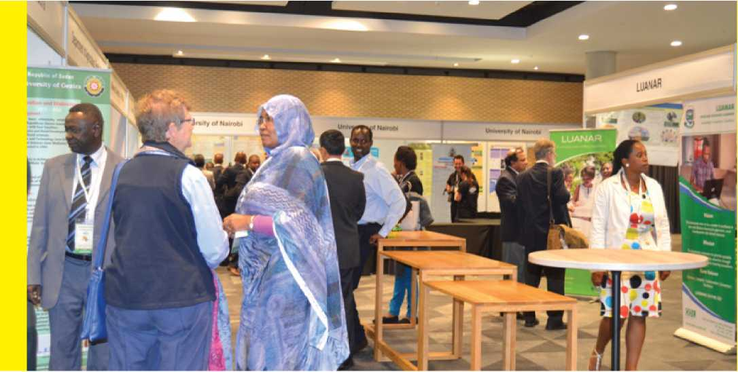

The competitive graduate research grant, on the other hand, secured by Dr. Jemal Yousuf, PI, has benefited MSc students from Agribusiness Management, and Rural Development and Agricultural Extension. The project has also benefited farmers in Babile District helping them to

adopt improved groundnut production to improve their income and nutrition.

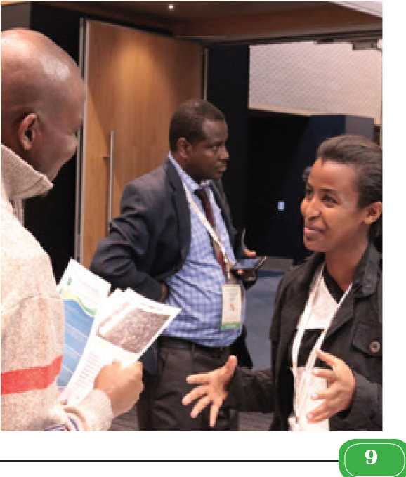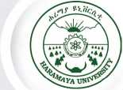

> Quarterly Newsletter

Issue 2 and 3, January 2017



Agricultural Experts Receive Training on Transferring New Technologies

Haramaya University’s Research and Extension wing organized a-two-day training on 24 and 25 October 2009 for 35 experts selected from Haramaya District in Haramaya Town.

The training included seven very important top­ics such as water resources and management, utilization of irrigation technology (drip), integrated soil fertility management, vegetables pre-and post-harvest practices, vegetables disease and pest management. Seven skilled professionals from the field ofhorticulture were involved in delivering these topics.

According to Mr. Teklemariam Keneni, a member of the University’s Research and Extension Directorate, the objectives of the training was to demonstrate and trans-is useful to boost experts’ knowledge and understand atti­tudes of people they encounter so that they can train and change them to maintain a positive and optimistic outlook about work and work environment.

The training participant appreciated the Universi­ty, the trainers and media personnel for the training they received which will enable them to solve farmers’ produc­tion problems by applying drip irrigation technology.

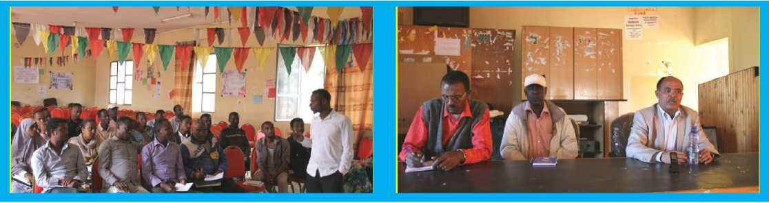

fer technologies/improved practices, show how to man­age water resources and utilize the irrigation technology (drip) as well as use integrated soil fertility management to end-users in order to improve their livelihood by creating sustainable agricultural production in the region.

Many relevant questions were raised by the partic­ipants and they actively attended the training. They were very eager to scale-up to 33 kebeles selecting model farm­ers who have the potential to implement drip irrigation technology to produce major vegetal crops like potato, cabbage, carrot, tomato, onion etc.

The closing remark was made by Professor Kebe- de W/Tsadik, Vice-president for Community Engagement and Enterprise Development. He said that such training



**Kersa** HDSS

*Goes*

"•Digital

Kersa Demographic Surveillance and Health Re­search Center (KDS-HRC) gave training to its personnel on automated data gathering, entry and management procedures. The training was conducted in two sessions from 22 September to 24 September, 2016. This training was given in light of the new advancement to change from the Household Registration System 2 (HRS2) the site was using to the new Open Health Demographic Surveillance (Open HDS). Kersa, as one of the HDSS sites in Ethiopia, is the first to apply the data collection mechanism using mobile devices.

In HRS2, data collectors and server needed to have physical proximity in order for the data manager to upload the collected data into the server, but now data col­lectors would upload the collected data and the data man­ager could access it while in office.

Error identification and notification are added features to the Open HDS. When errors were found, thedata manager had to go through the whole data to identify what has been done incorrectly, where, by who but in the Open HDS an email would be sent with the description of the erroneous data to notify the data manager.

The unlimited space provided by Open HDS is an­other feature that is an advantage to sites that use this plat­form. The HRS2 was subject to this problem as it would fill after it has been in use for some years. The programming language is also up-to-date in Open HDS, and this makes it convenient for users to find support online easily.

The user-friendly nature of the platform together with the lesser work process involved makes Open HDS the ideal data collection mechanism. Open HDS has no paperwork and the whole process is easy and shortened. It would also give ample time to data managers to analyze the data collected.

Ethiopia is the only country to have six HDSS sites in one country.

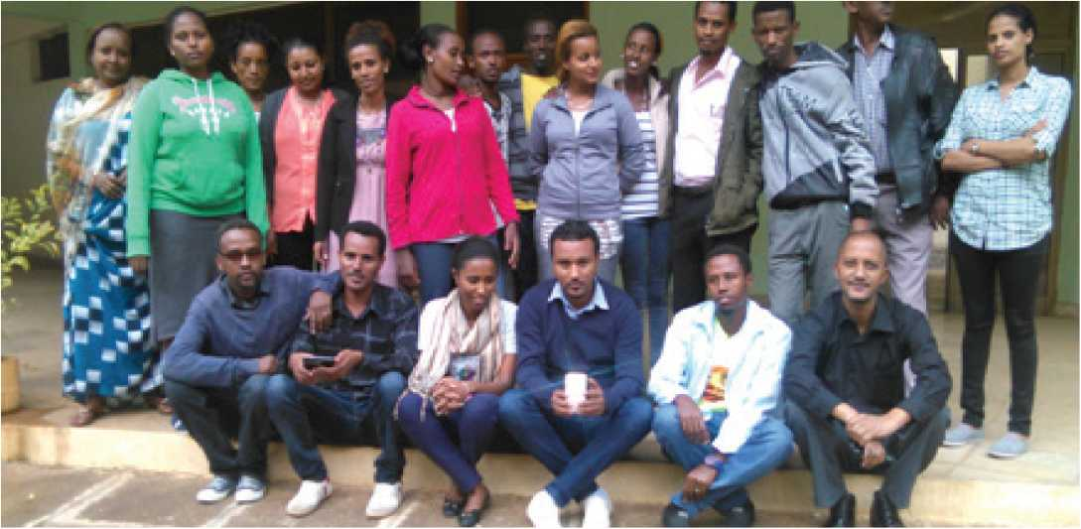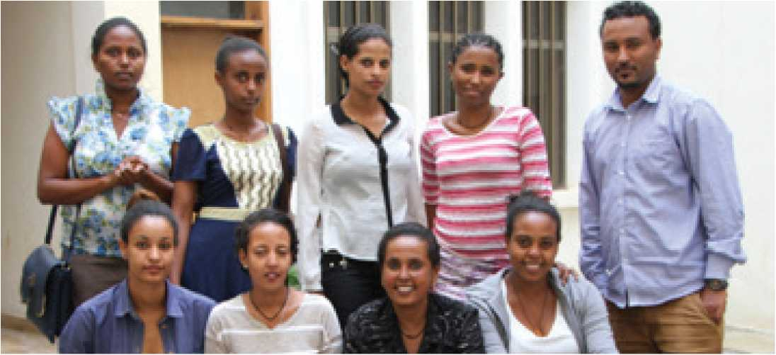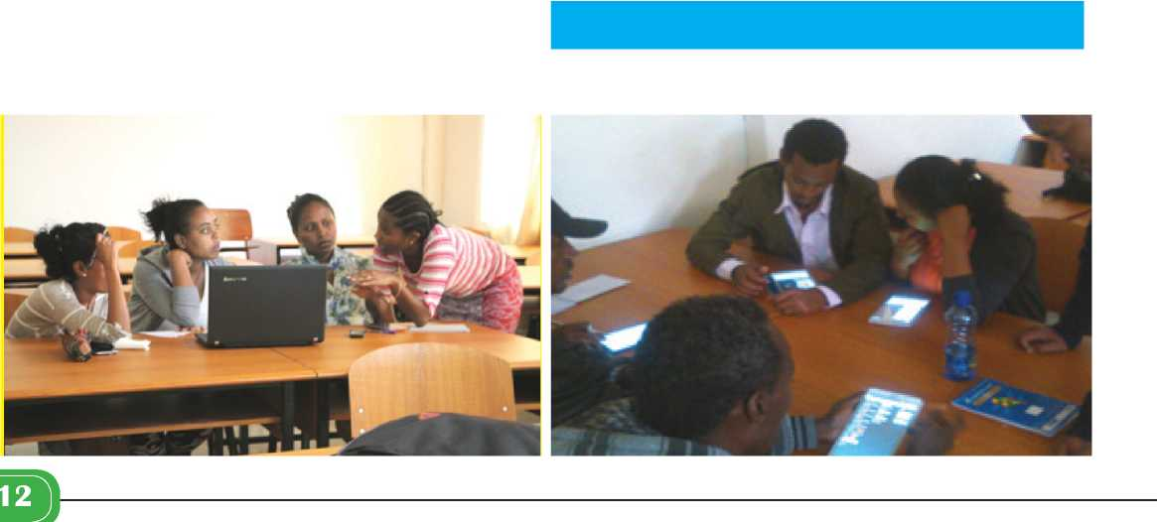

From the six HDSS sites in Ethiopia, Kersa HDS is the first to apply the mobile data collection application. The rest of the HDSS sites are expected to follow suit.

Kersa HDSS, which was established in 2007, is located in Kersa district of eastern Hararege, Oromia region, Eastern Ethiopia. It was with the vision of becoming center of ex­cellence in health science research in Ethiopia. It conducts health and demographic surveillance. The major work on the ground are monitoring demographic altering events such as birth, death, and migration; and health related conditions such as pregnancy, immunization, and mor­bidity. It also conducts verbal autopsy for the deceased to identify causes of death. It is an INDPTH network mem­ber site.

The site aims at generating up-to-date community based data including vital events; conducting studies ad­dressing national health need; assessing trends of demo­graphic, health and environmental changes; evaluating health intervention activities; enhancing research culture in the teaching and learning process; rendering support on research methods and analysis for students and staff; dis­seminate research findings to different users; and advocat­ing utilization of research findings to improve the health and other service delivery.



> Quarterly Newsletter

Issue 2 and 3, January 2017



**Reaching**

**ggBLocals**

Haramaya University’s Research Affairs Office has been working with the local people in Bate Town to bring about change in agricultural practices and production through farmers’ and youth associations. A number of ad­ministrative staff has taken seed to plant in their lands and individuals who belong to associations have been reached through the extension works of the Office.

Dishu: “What the University is doing is com­mendable.”

Mr. Abdi Abdulahi, people around campus know him as Dishu, is one of the employed drivers who give

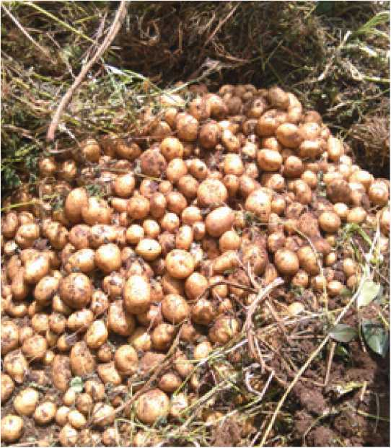

transportation services to the University staff. Dishu to­gether with his brothers maintains and manages their fam­ily farmland in Bate and this year he took three quintals of potato seed to plant on the family farm. Dishu said: “The production is estimated to be 10 quintals and I have people calling me to give them or to ask the University the potato seed for seed multiplication.” He said that he applied fer­tilizers on the disease resistant variety potato he received from the University. This enabled him to harvest higher production than that of his neighbors. He also emphasized that it would help the local people if it were coupled with trainings so as they know when best to plant, what kind of fertilizer to use and how to store in a good conditioned storage so the seed will not be ruined come next season.

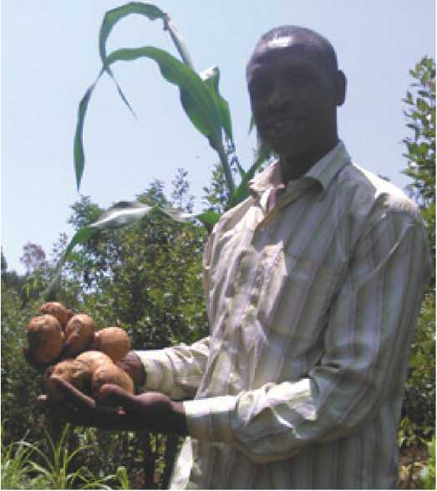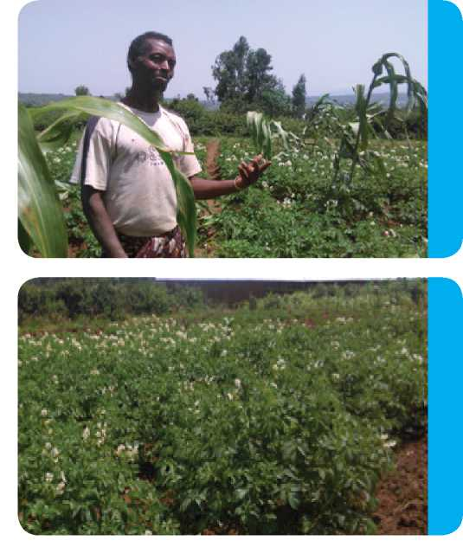

Dishu also laid emphasis on the help and support experts and researchers could extend in identifying and preventing diseases that would ruin productions. Unless these people are involved in the production process with the farmers, whenever plants are diseased, farmers would simply disregard the problematic variety as worthless; but if their field and practice is supervised continuously, their production would soar.

Dishu and his brothers do not belong to any kind of farmers’ association, and he said the local people, through associations or any other way, need to actively in­volve themselves and the University in the work they do. “They have to ask the University experts and researchers to look at their fields; and they should make continuous inquires so that the seeds they have taken give the maxi­mum production and profit” said Dishu.

Mohammed Abdulahi, Dishu’s brother said, “If the University is able to give us more seeds, we can pro­duce much more than we produced this year and we can sell back to the University and consumers.” Dishu and his brothers have supplied their potato production to the Uni­versity’s Staff Lounge.

Work with Youth

Research Office has also distributed seedlings and chicken feed to members of different youth associations. These young people rent farmlands in the surrounding ar­eas of Bate and produce cash crops and sell them in mar­kets in Bate, Harar and nearby towns. The collaborative works have been well received and showed that the Uni­versity is always open to change the lives of the locals when partnerships are formed.

Mohammed, chairman of one youth cooperative in Bate, approached the Research Office, and from the in­teraction and field visit, a team of experts was organized to assess areas where the cooperative could be supported. Accordingly, considering the cooperative as a model for technology incubation, full support was given including installation of drip irrigation facilities, provision of basic vegetable seed and soil fertility improvement.

The initiative has been successful and has at­tracted media attention from Oromia TV. It is also being promoted as a good model for youth employment in agri-

Associations

culture. As a model, the cooperative is targeted for other technology promotions such as poultry production.

Previously, the University has supported youth associations in Damota and Tinike with drip irrigation equipment, installation and basic seed. The introduction and maintenance of drip irrigation to dry areas serves to the appropriate and thrifty (economic) utilization of water during the dry season. The University’s Drip and Sprinkler Irrigation was a good demonstrative work that actually showed how farmers could be effective through using the technology.

These kinds of collaborative works and technolo­gy incubators do emphasis the University’s stand in being a public university serving the public in a way that em­powers the people by taking initiatives to reach out and disseminate new and improved technologies as extending a helping and supportive hand to the locals and giving trainings to equip them with the necessary knowledge can be beneficial to the University too. As no man is an island and no university should be too.



> Quarterly Newsletter

Issue 2 and 3, January 2017

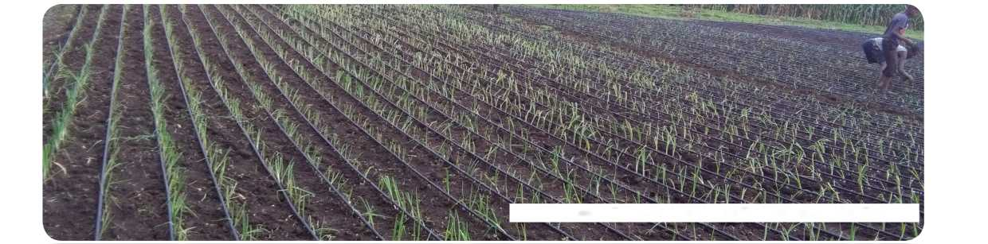

Drip Irrigation Technology donated to one Youth Association in Bate Town

Tony Farm Workers Appreciated

The Research Facilities Management Directorate in collaboration with Human Resource Management and Development Directorate held workers’ appreciation and recognition day in Tony Farm. The award ceremony which was the first of its kind to be held in the research site, wasstarted with an opening remark from Mr. Admkew Haile, Research Facilities Management Directorate Director. He said, “The recognition is for all not only for the selected awardees. This is just the beginning and we would like to thank you all for the work that you’ve done so far"

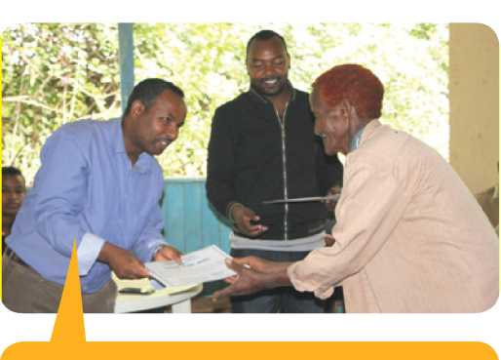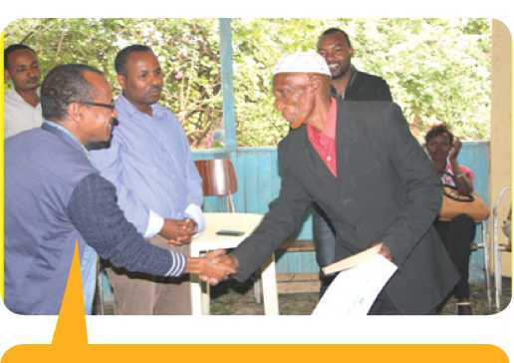

Dr. Mengistu Ketema, Research Extension & Publica­tion Directorate

Mr. Minda Gelay, Human Resource Management & Development Director

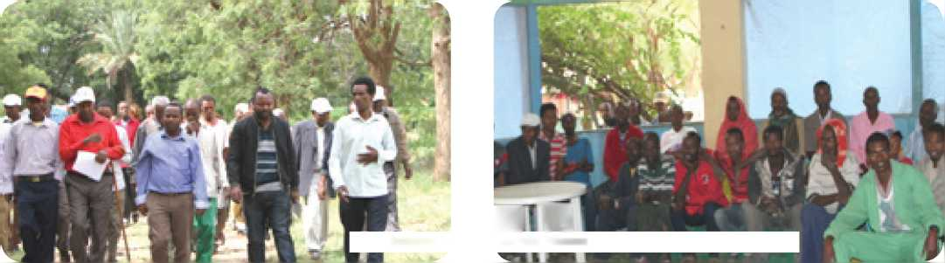

Awardees and participants expressed their ap­preciations and gratitude for the recognition and the dis­cussion opportunity. During the discussion the workers pointed out that the University has made improvements in recent years, and the appointment of the site manager, Mr. Shibru Wakjira has made a noticeable change in the main­tenance of the site. Mr. Shibru, together with the workers of the research site, has done a tremendous job.

Dr. Mengistu Ketema, Research Extension and Publication Directorate Director, said: “It would be great to make this an annual event where we would have a ‘Tony Day to celebrate the farm workers, their hard work and achievements”.

Employees also pointed out issue of concern such as lack of transportation service, medical facility, uniforms and field shoes, ID card for permanent workers and water well maintenance and fence construction. Dr. Mengistu said some things take time to be addressed and others can be quickly resolved and with the discussion that took place, it has become easier to identify which ones are pri­ority areas. Mr. Admikew in his part said that the fence construction issue might not be resolved quickly as there is a body that handles constructions of University com­pounds. He said, “We would contact them and see how things progress, but if it is not solved quickly, we might do it through our office. Well see how things go.”

Discussion and Field Visit with Workers

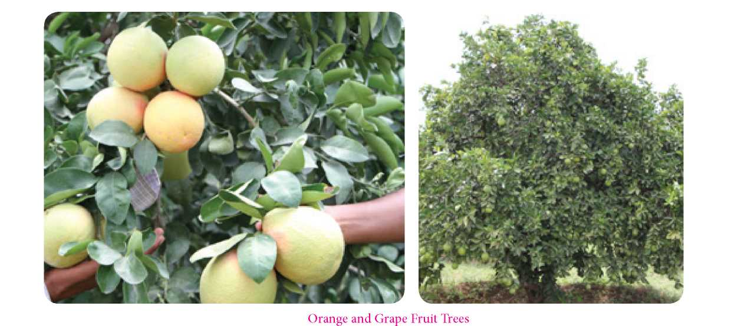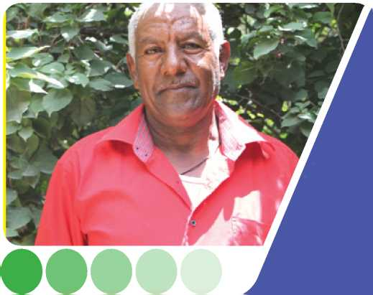

Ato Yimer Ayalew, who started work at Tony Farm in 1992, expressed his joy and appreciation of the recognition event. He said, “The work we’ve done brought us this recognition and we would add on what we’ve been doing. Others would be encouraged by what has been done today.”

Ato Yimer Ayalew

Mrs Ejigayehu Birkneh, who has been working at Tony Farm for more than 30 years said, “The recognition and appreciation event should be made on a regular basis and other directorates and offices of the University could take something from this experience. When em­ployees are happy and feel like they have a say in matters of their concern and when they are recognized for their hard work, a positive work envi­ronment can be created and productive employees could be produced.’’

Mrs. Ejigayehu Birkneh

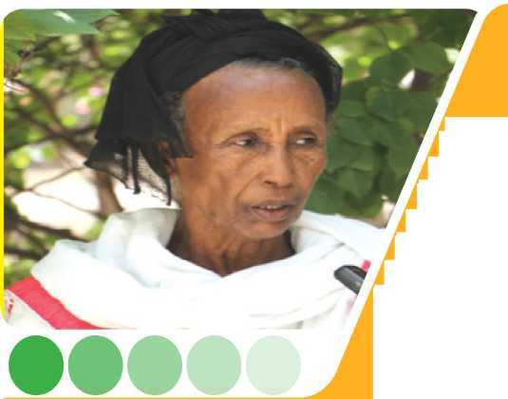

***W***

Partnership with Fair Planet

HU in partnership with Fair Planet, Israel-based NGO, is implementing a project aimed at improving farmers’ access to improved vegetable seed (tomato, pepper) that meet market demand.

Certified seed from a known global seed company has been test­ed with full participation of farmers. The process enabled the transfer of knowledge from experts to farmers, and brought together key stakeholders (farmers, development agents, Bureau of Agriculture and seed producers). Project farmers’ testimonies show yield gain of fivefold than what could have been obtained using local varieties.

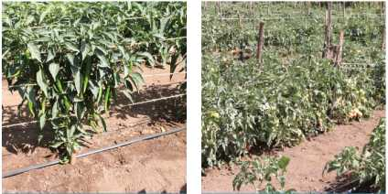

Communication Needed between Research, Policy and Media

A national workshop on “Evidence for Health Ac­tion: Research to Policy Divide” was held at Capital Hotel & Spa in Addis Ababa on August 19, 2016. The workshop looked at the link and communication between health researches and policies on health as well as the linkage between health researches and their media reports, and the possibility of creating a formal network whereby the stakeholders of the health sector could converse with each other.

Dr. Fikreab Kebede from Ethiopian Public Health Association (EPHA) gave the keynote speech and he addressed the need for conducting and communicat­ing research findings and reports to the public. He said, “Communication and collaboration between research in­stitutions, researchers, Health Demographic and Surveil­lance System (HDSS) sites and different stakeholders needto strengthen” if we are to develop the country’s health profile. An issue that was raised with equal importance is the communication between media outlets and their re­search counterparts. Dr. Firkreab pointed out that “The Ministry of Health (MoH), universities and media should collaborate and disseminate information that is of value to the public and they need to be careful of what they dis­seminate as well.”

Around half a million people are being addressed through the six HDSS site in the country; and the estab­lishment of a network between these sites would give op­portunities for learning and sharing of knowledge, skills and mentorship. This network according to Mr. Fasil Tes- sema from Jimma University “can create a platform to share the longitudinal data among the six HDSS sites and help researchers with the vital data to address the many health related issues of the country”



**Organised by Health and Demographic Surveillance - Ethiopian Universities Research Centers Network in Collaboration with**

Ethiopian Public Health Association

**Capital K»t«l nid Spa, Atldlt Ababa, Ethiopia, 1? August 2016**

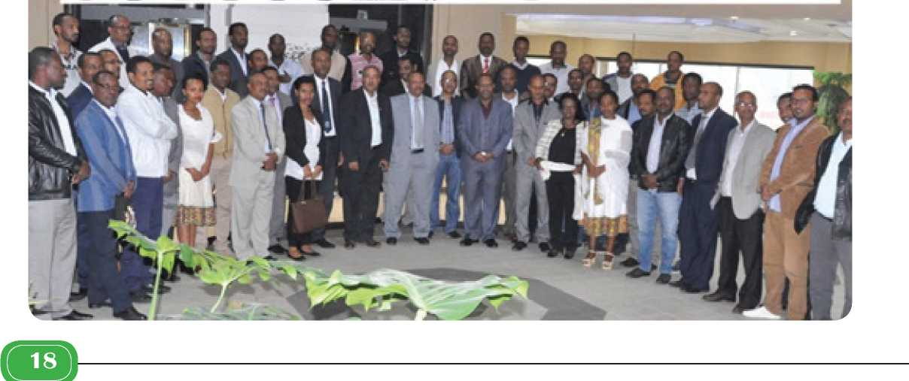

> Quarterly Newsletter

Issue 2 and 3, January 2017

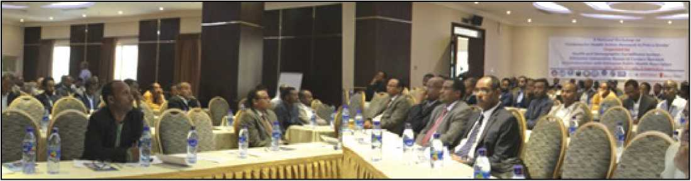

Presentations were made on the current practic­es in the country with regard to the integration between health research and policy, health research communi­cation and media, Mother, Newborn and Child Health (MNCH) research to policy practices, information revolu­tion in relation to MNCH, fertility pattern and health ser­vice utilization, and child and maternal mortality causes and findings. Representing the Kersa HDSS site which is maintained by Haramaya University, Dr. Nega Assefa pre­sented key findings on “Neonatal, Infant, Under Five and Maternal Mortality and their Causes” findings from all the HDSS sites around the country

Panel discussion were made on raising issues from the presentations and on current practices in the country Having a middle ground in prioritization between policyequipping would-be journalists with the ethics, skill and knowledge of research reporting; the collaboration of and information sharing between the HDSS sites; and active engagement of MoH, Vital Events Registration Agency (VERA), universities, research institutions and the media in the generation, utilization and dissemination of surveil­lance and research outputs were some of the major discus­sion points.

At the end of the workshop, recommendations for the way forward were suggested and a two months’ time­table was given for the proposal development of the formal establishment of a network for the research centers oper­ating under universities. Equipping media personnel with the skill and knowledge of the how to’s of research report­ing, incentivizing and encouraging researchers and data collectors for the quality and quality of data generation,

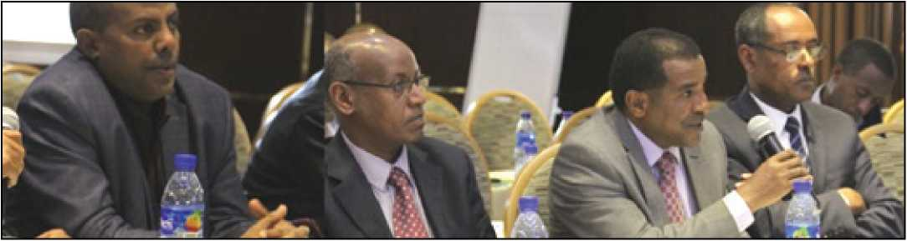

makers and researchers, for both work for the betterment and well-being of the public; striking a balance between basic and scientific research so that the theory and practice of things grows in a parallel manner than one overshad­owing the other; identifying the issue of rhetoric and actu­al communication and opportunity exploitation between the media and research institutes as well as researchers; the lack of airtime and print space for technology, science and health; the capacity of the universities of the country inand diversifying the finding opportunities for HDSS activ­ities were also recommended to continue and integrate the tremendous work the HDSS sites are working.

The workshop was organized by EPHA, MoH, CDC, INDEPTH Network, Save the Children, and HDSS sites under Addis Ababa, Haramaya, Gondar, Jimma, Me- kelle and Arba Minch universities, and had more than 70 participants.

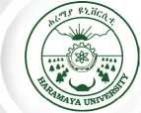

> Quarterly Newsletter

Issue 2 and 3, January 2017

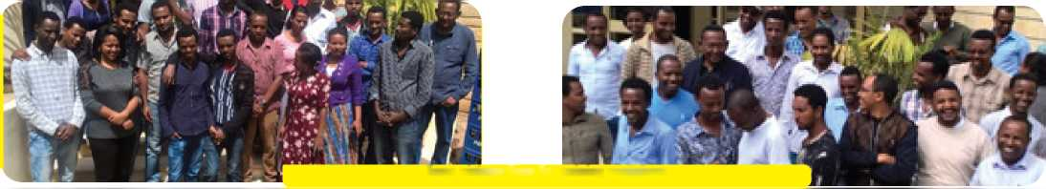

Research Capacity Building for Improving Quality of Theses and Dissertations

Building Ethiopia’s Research Capacity in Econom­ics and Agribusiness (BERCEA) project is a two-year proj­ect funded by the Global Development Network (GDN). It is a project coordinated by two staff members of the School of Agricultural Economics and Agribusiness, Dr. Mengis- tu Ketema (coordinator) and Dr. Degye Goshu (assistant coordinator). The major aim of the project is to build re­search capacities of post-graduate students and theirby improve quality of theses and dissertation research.

The major areas of interventions that the project has im­plemented included small research grant to postgraduate students, training workshops, and staff exchange and net­working activities. Under its small research grant scheme, the project has offered a full-thesis research fund tor 18 MSc students and partial research fund tor 5 PhD stu­dents. All except one of the MSc grant awardees have suc­cessfully defended their theses while one will be defending by next January 2017.

Under the training workshop, the project has of­fered four important trainings on various topics: Empiri­cal Research Methods in Economics in two rounds, Anal­ysis of Cross-sectional, Timeseries and Panel Data Using Stata and Eviews in two rounds, Analysis of Multidimen­sional Poverty and Inequality Using DASP in one round, and Computable General Equilibrium (CGE) Modeling and Analysis Using GAMS in one round. These trainings have substantially improved research and econometric skills of the post-graduate students. Some junior staff members also participated in these training workshops. Under its staff exchange and networking intervention, two staff members stayed for a total of two months (in two rounds) in Germany where they have obtained experienc­es in post-graduate mentoring and supervision skills.

Up on their return these staff members are trying to de­velop joint projects with the host institution in Germany (Humboldt University of Berlin).

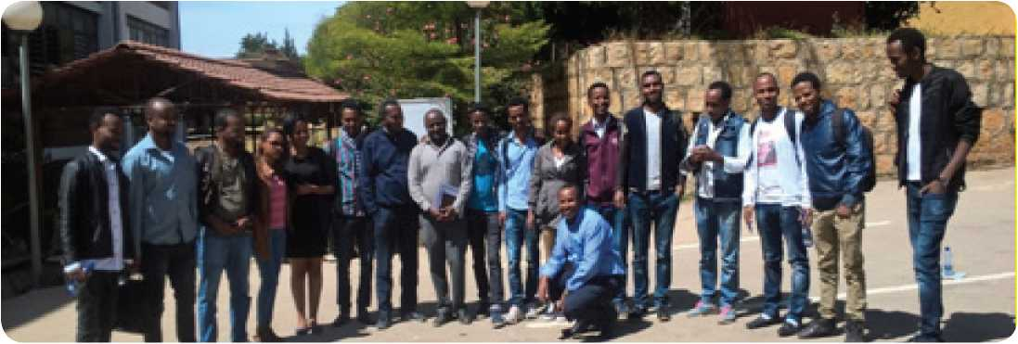

Some pictures from the training workshops



Coordinators of the BERCEA project, Dr. Mengis- tu Ketema and Dr. Degye Goshu, are also coordinating an­other project called Value Chain Development for Food Security in the Context of Climate Change (ValueSeC). ValueSeC is an EU funded collaborative project of Hum­boldt University of Berlin in Germany, Haramaya Univer­sity in Ethiopia, and University of Nairobi and Karatina University in Kenya. Offering trainings, conducting stu­dent study projects, and organizing national workshops are among the major activities of the ValueSeC project. The project has offered two rounds of trainings. A study project has also been undertaken in the Ethiopian Rift Val­ley by focusing on vegetable value chain where MSc stu­dents from Haramaya and Germany have been involved together with their supervisors. The project is currently organizing a conference with a theme Agricultural Value Chains and Climate Change and a joint study project of MSc students from Germany (Humboldt University) and Ethiopia (Haramaya University)

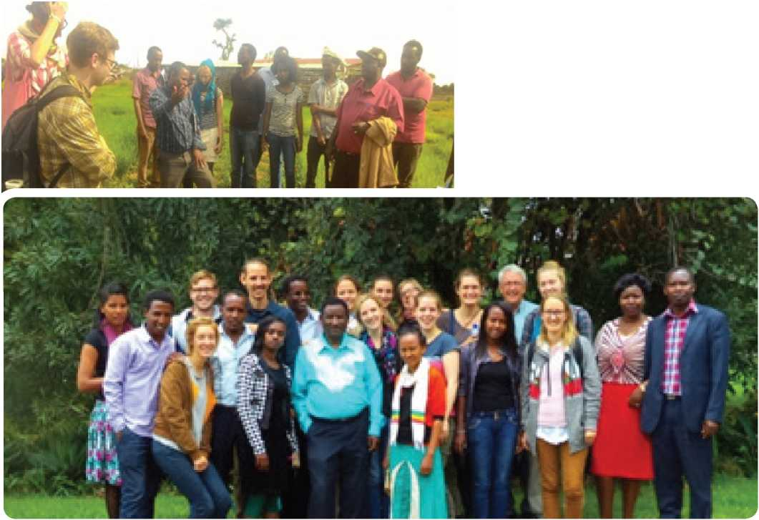

> Quarterly Newsletter

Issue 2 and 3, January 2017



University Alerts Possible Wheat Rust Outbreak

Wheat rust disease (locals know it as ‘Wag’) is a crop-killing fungus which is threatening recent crop produc­tions in many part of Ethiopia, following the long period of El-Nino-induced drought. Wheat rust is known to cause stunting in plants and pre-harvest losses of between 50 and, in severe cases, 100 percent, according to a FAO report.

A team of expert from Haramaya University had observed severe occurrence of leaf rust on wheat in Jarso and other wheat growing areas by undertaking a survey. Following this the Univesity has alerted concerned offices in East Hararghe Zone, Harari Region and Dire Dawa City Administration and recommended actions to be taken by the con­cerned stakeholders before the outbreak causes a severe loss.

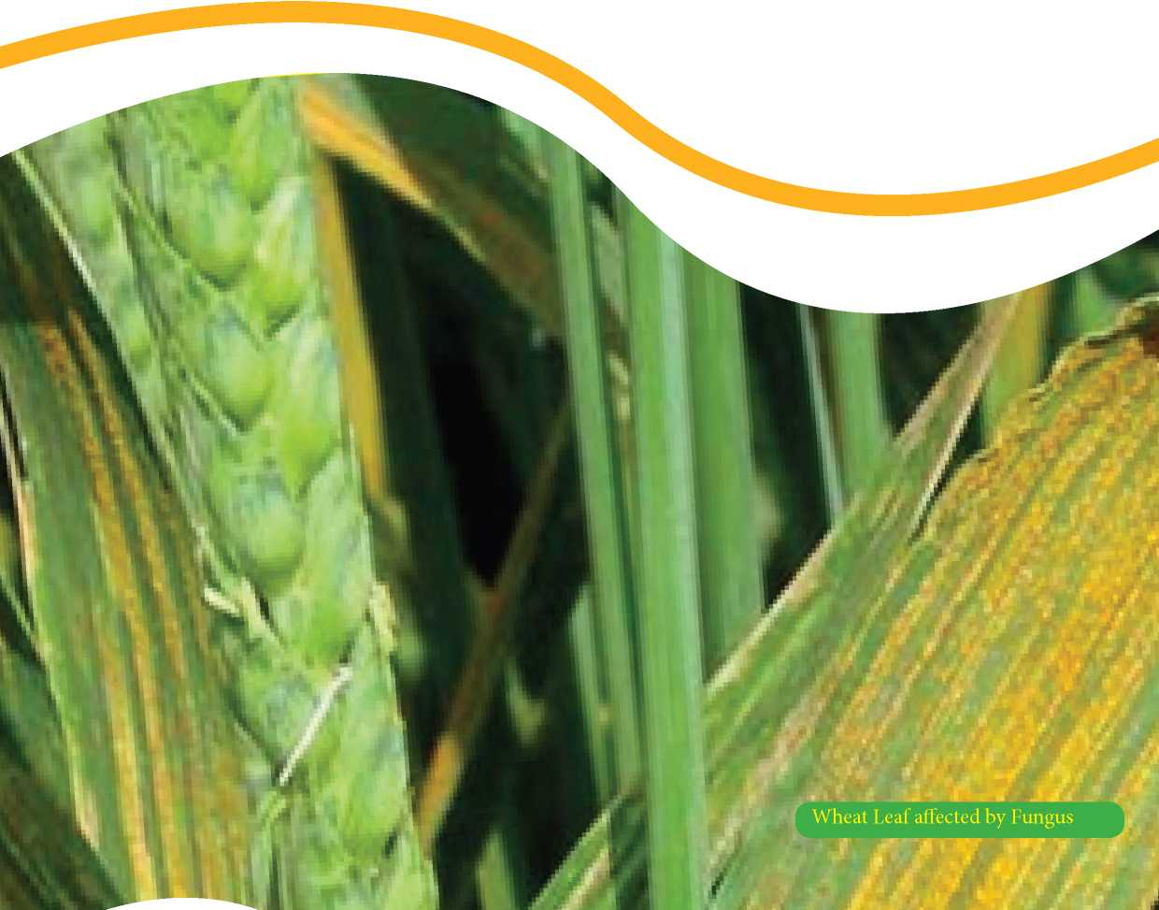

Haramaya University Establishes New Research Site



Owing to the ever-increasing demand for research outputs, the University firmly believes that it is necessary to increase the number of research stations in various agro-ecologies; as this would enable the University to broaden the scope of research in terms of the commodities to be researched and the problems to be addressed. In view of this, the University has negotiated with Babile District Administration Office and other concerned offices in the district and has secured a very convenient research sta­tion in Babile District with a size of 50 hectares. This has brought the total research stations of the University to sev­en excluding the on-campus stations. The Research Affairs Office of the University has great appreciation for the will­ingness and cooperation rendered from the side of the var­ious offices of the Woreda including the Administration Office. The research station will be used for undertakingbroad research activities including research on fruits and vegetables, cereals, pulses, goat, camel and others. Land clearing, plowing, demarcating, and planning activities have already been started and the actual research will be follow soon.

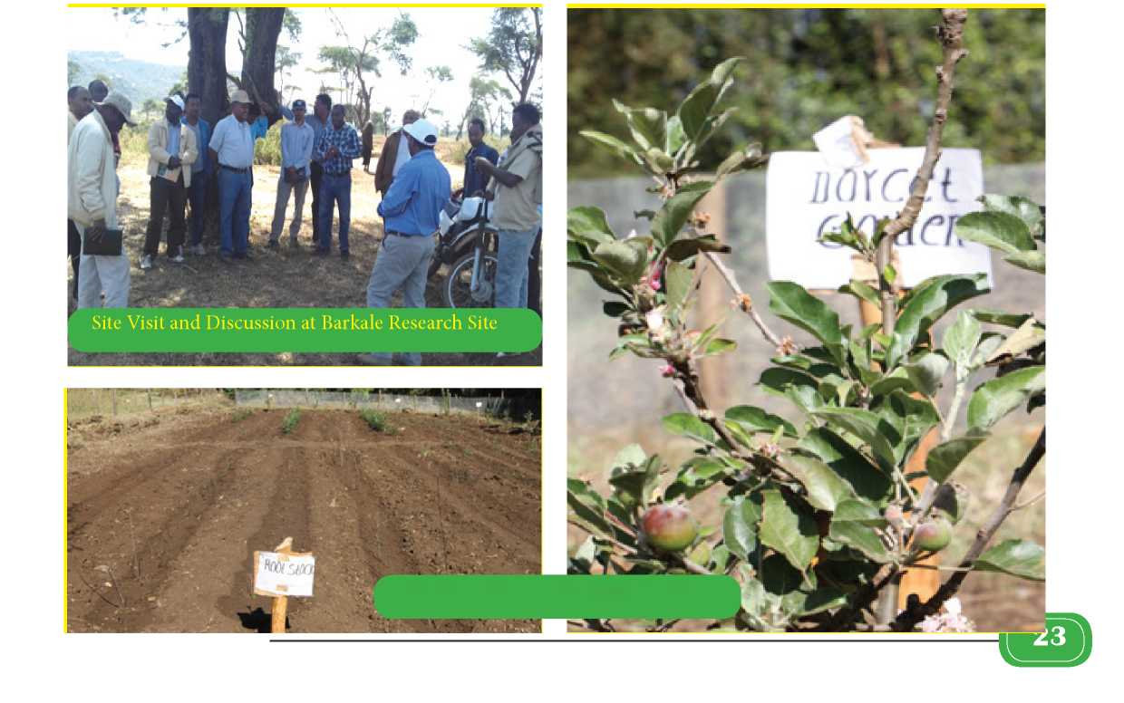

The Research Facilities Management and Re­search Extension and Publication directorates organized a site visitation day with researchers and have started work immediately so that they can respond to the communi­ty’s demand. In addition, the University has established an apple root stock maintenance site at Gurawa District. The purpose of this root stock is to maintain different va­rieties of apple and to distribute them to the community. The University also plans to conduct research on highland fruits

Root Stock at Gurawa Research Center



Sesame Varieties Released in 2016

New Sesame Varieties: BaHa-zeyit and BaHa-necho

Varietydescription

|  |  |  |
| --- | --- | --- |
| Description | Variety | |
| BaHa-zeyit | BaHa-necho |
| Adaptation | Eastern Ethiopia (Gursum, Babile, Bisidimo and similar agro-ecologies in Ethiopia) | Eastern Ethiopia(Gursum, Babile, Bisidimo and similar agro-ecologies in Ethiopia) |
| Altitude (m.a.s.l) | 560-1650 | 560-1650 |
| Rainfall (mm) | 550-685 | 550-685 |
| Planting date | End of June-mid-July | End of June - mid-July |
| Seed rate (Kg ha-1) | 2-3 (row planting), 3-4 (Broadcasting) | 2-3 (row planting), 3-4 (Broadcast­ing) |
| Days to flowering | 60-74 | 60-73 |
| Days to maturity | 113-134 | 114-129 |
| Plant height (cm) | 113-160 | 110-150 |
| Reaction to pest | Moderately resistant | Moderately resistant |
| Hundred seed weight (g) | 2.8 | 2.7 |
| Seed/grain yield |  |  |
| Research field (Qt ha-1) | 13 | 12 |
| Farmers' field (Qt ha-1) | 10-13 | 8-12 |
| Seed color | Light gray | White(export quality) |
| Crude oil(%) | 56(not registered before) | 52 |
| Protein (%) | 27.1 | 23.8 |
| Year of release | 2016 | 2016 |
| Institution (breeder) | Haramaya University | Haramaya University |
| Principal Investigator (Breeder) | Mr. Amare Kebede (Assist. Prof.)  +251 9 13 04 81 06 | Mr. Amare Kebede (Assist. Prof.) +251 9 13 04 81 06 |
| Financial support: Haramaya University and Ethiopian Institute of Agricultural Research | | |

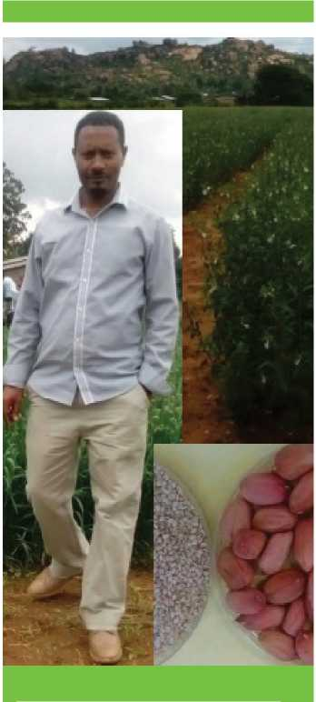

**Researcher**

**Amare Kebede**

**Assistant Professor**

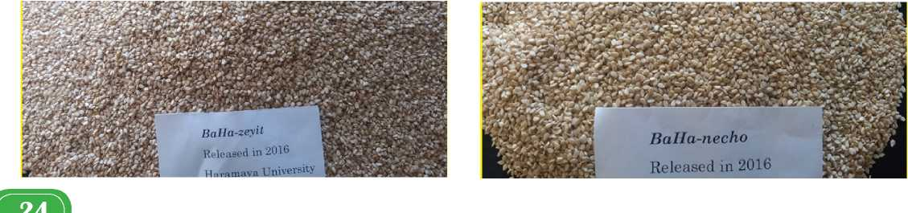

Newly Released Groundnut Varieties

**Variety description**

|  |  |  |
| --- | --- | --- |
| Description | Variety | |
|  | Babile-1(ICGV-98412) and Babile-2(IC- GV-98404) | Babile-3(ICGV-94100) |
| Adaptation | Babile, Pawe, Assosa, Werer, Miesso, and similar agro'ecologies in Ethiopia | Babile, Pawe, Assosa, Werer, Miesso, and similar agro-ecologies in Ethiopia |
| Merit | Confectionery (large seed' ed) | Tolerant to leaf spot; Medium seeded |
| Pod yield(Qt ha'1) (Good agronomic management required) | 24 (Babile-1) and 20 (Ba- bile-2) | 24 |
| Crude oil (%) | 49 (Babile-1) and 51 (Ba- bile-2) | " |
| Seed color | Tan red | Tan red |
| Growth habit | Erect | Erect |
| Planting date | Mid-April - May | Mid-April - May |
|  | (onset of rainfall) | (onset of rainfall) |
| Days to maturity | 120 -130 | 125 -135 |
| Year of release | 2016 | 2016 |
| Institutions (breeder) | Haramaya University | Haramaya University |
| Investigators | Amare Kebede, Seltene Abac | i and others |
| In collaboration with Ethiopian Institute of Agricultural Research | | |

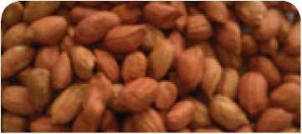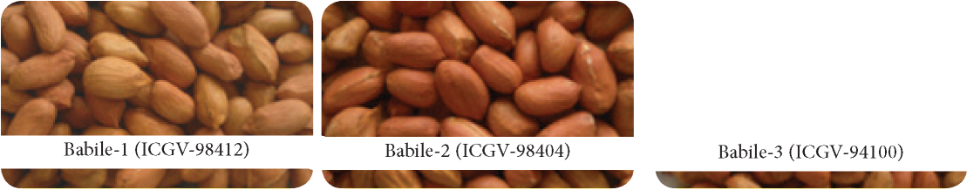

Haramaya University Research Stations/Center

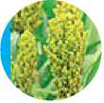

Fedis Research Station

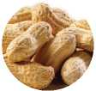

Babile Research Station

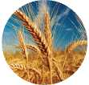

Hirna Research Station

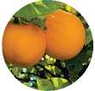

Dire Dawa Research Station (Tony Farm)

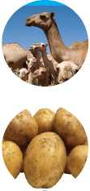

Eror Research Station

Gurawa Research Station



Berkele Research Station

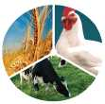

Haramaya University Research Station

Kersa Health and Demographic Surveillance System Center

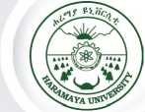

> Quarterly Newsletter

Issue 2 and 3, January 2017



**Haramaya University Research Themes andSub-themes**

Theme 1: Productivity and Environmental Sustainability for Food Security and Poverty Alleviation

**Sub-themes:**

1. Animal Production and Health
2. Plant Production and Health
3. Environment, Natural Resources, and Climate Change

Theme 2: Human Health, Nutrition, and Welfare

**Sub-themes:**

1. Health Promotion and Disease Prevention
2. Advances in Curative and Rehabilitative Health Services and Disease Management
3. Nutrition, Food Safety and Security, Dietetics, and Nutritional Problems
4. Reproductive Health, Maternal and Child Health

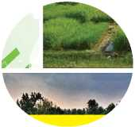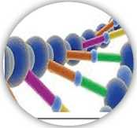

Theme 3: Energy, Engineering, and Information Technologies

**Sub-themes:**

1. Information Technology and Computing
2. Advanced Material Research and Development
3. Energy Resource Development and Utilisation
4. Postharvest Technology, Processing, and Food Analysis
5. Civil Infrastructure, Manufacturing, and Industrial Technology

Theme 4: Human and Social Development

**Sub-themes:**

1. Society, Culture, and Tourism
2. Educational Advancement and Quality Assurance
3. Population, Gender, and Development
4. Governance and the Rule of law



Theme 5: Institution, Innovations Systems and Economic Development

**Sub-themes:**

1. Economic Development, Policy, and Institutional Analysis
2. Innovation Systems and Impact Evaluation Studies

Theme 6: Basic Science Research

**Sub-themes:**

1. Bioscience Research
2. Chemical Science Research
3. Biophysics and computational physics
4. Mathematical Research



Haramaya University Journals

Haramaya University has launched new journals to provide options of publication platforms for worldwide scholars, in addition to its previous journal (East African Journal of Sciences).



The following journals are now available for you to publish your research articles, review papers, variety registrations, case studies, and short communications.

1. **East African Journal of Sciences (EAJS)**

Areas of Publications: Agricultural sciences, natural sciences, environmental sciences, social sciences, health and medical sciences, veterinary sciences, and other related disciplines.

Submission Address Editorial Manager: Dr Adem Hiko Tel:+251 255 530 045

<http://www.haramayajoumals.org> (for online submission)

Email: [aueastjs@gmail.com](mailto:aueastjs@gmail.com)

1. **East African Journal of Social Sciences and Humanities (EAJSSH)**

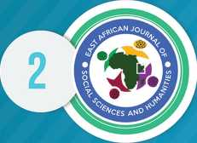

Areas of Publications: Social sciences and humanities such as history, sociology, social work, anthropology, geography, political sciences, linguistics and language studies, semiotics, conflict and peace studies, social psychology, education, media, culture and communication studies, and other related areas.

Submission Address Editorial Manager: Mr. Birhanu Midakso Tel:+251 911824509/+251 255 530 091 Email: [eajssheditorialoffice@gmail.com](mailto:eajssheditorialoffice@gmail.com)

1. **East African Journal of Health and Biomedical Sciences (EAJHBS)**

Areas of Publications: All aspects of health and medical fields across all scientific disciplines including but not limited to biomedical sciences, epidemiology, clinical sciences, and other public health fields.

Submission Address

Editorial Manager: Mr. Tesfaye Digaffe Tel: +251 254-660 031 <http://www.haramayajoumals.org> Email: [eajhbs@gmail.com](mailto:eajhbs@gmail.com)

1. **East African Journal of Veterinary and Animal Sciences (EAJVAS)**

Areas of Publications: Related to veterinary and animal sciences encompassing economically important large and small farm animals, poultry, equine species, aquatic species, and bees, as well as companion animals and laboratory animals. Furthermore, basic sciences and clinical sciences related to veterinary medicine, nutrition, and nutritional diseases, as well as the breeding and husbandry of the i above-mentioned animals and the hygiene and technology of food of animal origin, and related aspects

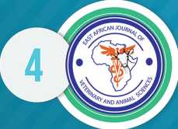

O' ^ UjVrt



| of life sciences at molecular level or environment and animals (or humans), biotechnology and related

disciplines.

Submission Address

Editorial Manager: Dr. Tesfaheywet Zeryehun Tel: +251-255-530 334/ +251-920556154 Email: [hueajvas@gmail.com](mailto:hueajvas@gmail.com)

1. Haramaya Law Review

Areas of Publications: Legal topics relevant to the Ethiopian legal community, including analysis of domestic or international laws and cases, and international organizations; case and legislative reviews; and notes. Scope: Legal topics relevant to the Ethiopian legal community, including analysis of domestic or international laws and cases, and international organizations; case and legislative reviews; and notes.

Submission Address

Editorial Manager: Mulugeta Getu

Tel: +251-255-530084/ +251-911-807861

Fax: +251-255-530102

Email: [mulugetagetu23@yahoo.com](mailto:mulugetagetu23@yahoo.com)

Further Information: Mrs. Kidesena Sebsibe, Publication Officer, Tel: +251 255 530 045 Website: http//[www.haramayajournals.org](http://www.haramayajournals.org)