**Special Edition**

**Newsletter**

**Inside this Issue**

**FlAflVSfth**

lnrf|Efi

**Annual Research and Extension Review Workshop**

**21-24 April 2016 Haramaya University**

l\niFPTH

I'VISnHhDfUl

Cff'JlCH'Kf

**:nd Amtiii**

Gcner-ii

**MKtini Ud**

1-

**Kl Hum-,** n-

R(; and sni^iw iT-ftidDn

T^hnni-

f :i-S'ihikw II■ i ilppl hH

■Vl-nJlVTf

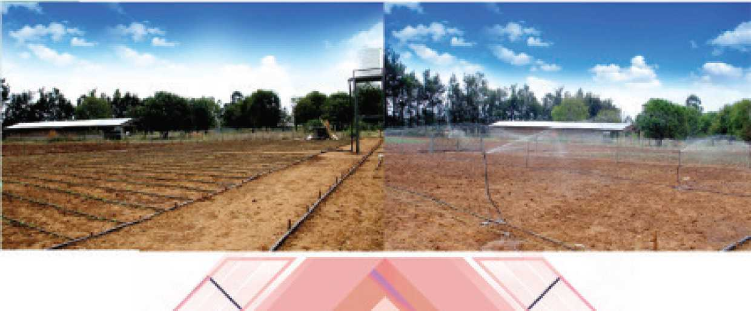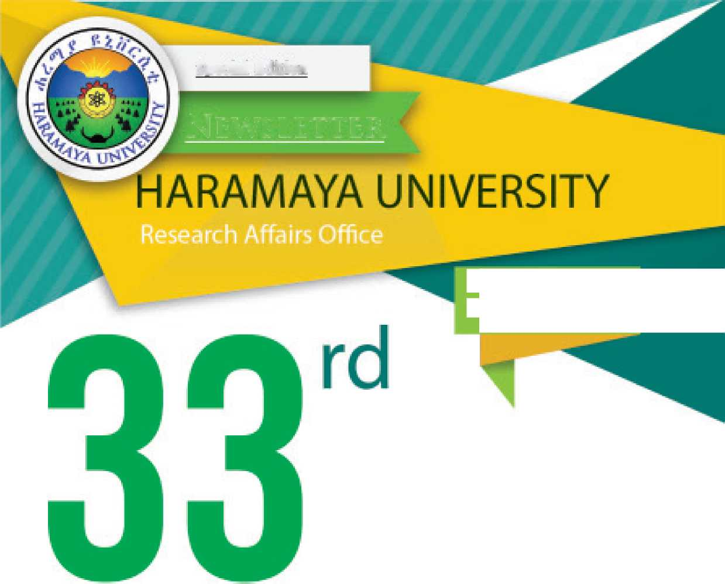

**13th INDEPTH International Conference and Annual General Meeting held in Addis**

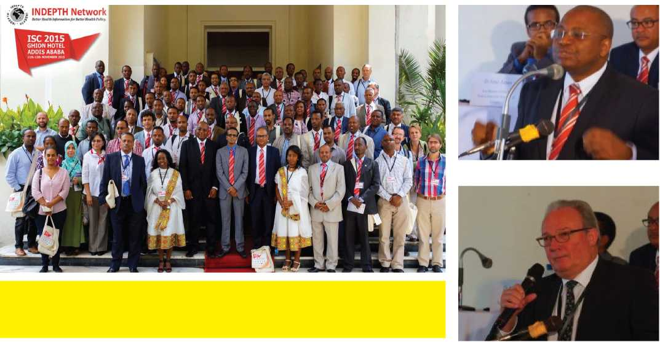

The 13th International Network for the Demographic Evolution of Population and Their Health (INDEPTH) interna­tional conference was successfully con­ducted from November 11th -13th 2015 at Gliion Hotel Addis Ababa. ISC-2015 was hosted by Haramaya, Addis Ababa, Gondar, Jimma and Mekele Universities in collaboration with INDEPTH, WHO and the FDRE Ministry of Health.

The conference was officially opened by the honorable guest His Excellency, Dr. Amir Aman FDRE’s Minister of Health. During his opening remark Dr. Amir emphasized reliable, timely and accurate data were basic for better health policy formulation.

In the three day conference held at the Ghion Hotel various scientific papers have been presented and fruitful discus­sions were held both on plenary andparallel sessions. Dr. Nega Assefa (PhD) Site lead of Kersa Health and Demo­graphic Surveillance System (Kersa HDSS) presented a paper on Neona­tal and Infant mortality and causes of death in Kersa Health and demographic Surveillance System in the period from 2008-2013.

In addition, Ato Wondimye Ashenafi, Ato Desalew Zelalem, Ato Yadeta Dessie and Ato Abere Shiferaw, all from Haramaya University presented their papers in the forum. Ato Abere Shiferaw was a partici­pant of the Young Scientist Forum among the 9 researchers selected from all over the world.

The INDEPTH International Scientific Conference (ISC) was concluded by electing four INDEPTH board members replacing those finishing their tenure. Prof. Alemayehu Worku of Addis Ababa University is among the four scientistsselected for INDEPTH board member. At the conclusion of the program, Uganda and Thailand were given the chance to host the AGM in 2016 and ISC in 2017, respectively.

INDEPTH is a network of Health and Demographic Surveillance System (HDSS) all over the world, and organizes International Scientific Conference (ISC) and Annual General Meetings (AGM).

It is a pioneer in health and population research, providing robust answers to some of the most important questions in development. Through its global network of health and demographic surveillance system (HDSS) field sites in Africa, Asia and Oceania, it is capable of producing reliable longitudinal data not only about the lives of people in low- and middle-in­come countries, but also about the impact on those lives of development policies and programs.

1

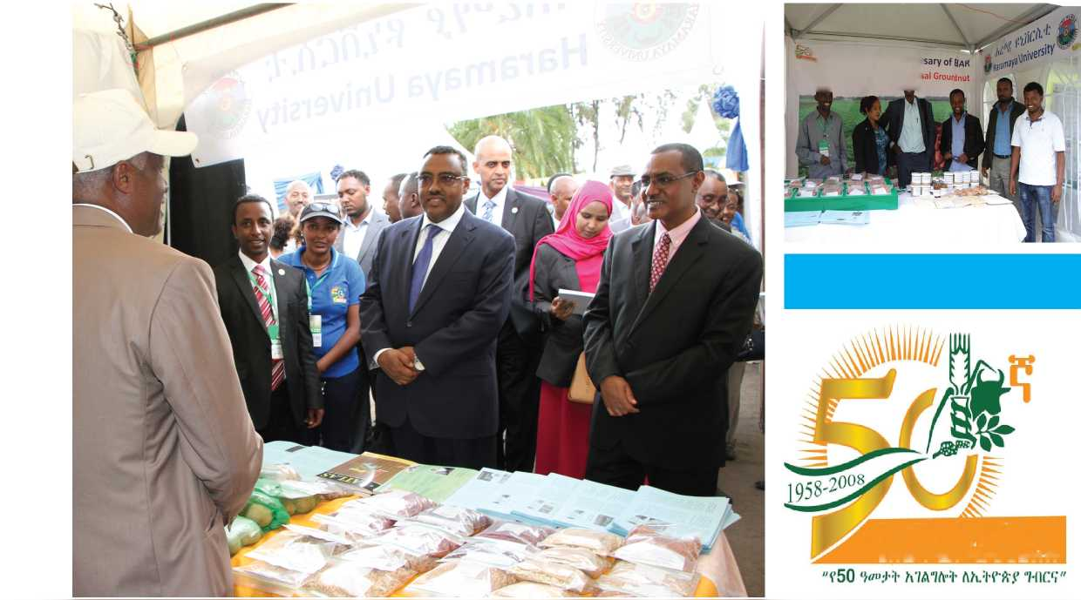

**HU attends ElAR's 50th Jubilee Celebration**

Haramaya University attended the ex­hibition organized to celebrate the 50th Golden Jubilee of Ethiopian Institute of Agricultural Research (EIAR) in Addis Ababa. The exhibition took place from the 25th - 27th February, 2016 at the head quarter of the institute. EIAR was celebrating its achievements and contri­butions to Ethiopian agriculture with the motto “50 years of Service for Ethiopian Agriculture”. The exhibition was a show of collaborations EIAR had had over the years with universities, research centers and different stakeholders.

The exhibition was officially commencedwith a speech from FDRE’s Deputy Prime Minister, Ato Demeke Mekonnen; and in attendance were His Excellency, Ato Tefera Deribew, Minster of Ministry of Agriculture and Natural Resources (MoANR), Ato Addisu Legesse and honorable guests. Also attending were former academic and administrative staff members and students of HU.

HU has been in collaboration with EIAR since the institution’s inception in 1966 and graduates of the University have served the institution throughout its ser­vice years. HU has exhibited its succes­sion of improved varieties of cereals and

pulses. In addition, researches results of camel products, mushroom and develop­ments in bio-fertilizers were also shown to the exhibitors.

The reaction from exhibition viewers and former affiliates of HU was overwhelm­ing and the three days exhibition was a success. The University has received an appreciation certificate and commemora­tive trophy at the official closing ceremo­ny held at on 28 February for its contri­butions in the Groundnut research sector and the partial sponsorship it provided for the anniversary celebration.

" , Golden Jubilee Annivei

**Welcome to Exhibition of l^0r ^ Research PrdHn**

**PDlOl- li f t I, h v**

**aim run:1; yin: h/miv-t**

2

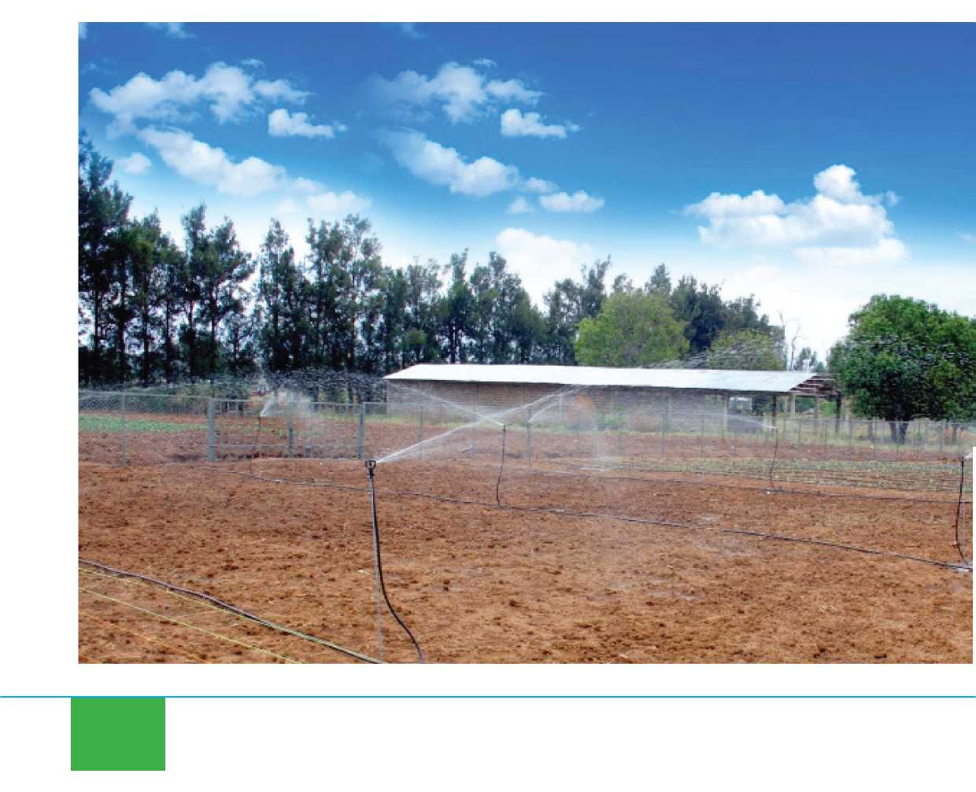

**HU Launches Drip and Sprinkler Irrigation Technology**

H

aramaya University has launched a Drip and Sprinkler Irrigation Technology in its Rare Research Site located inside the main campus. The irrigation technology is the first of its kind for the University and is installed on % hector farm land. This new addition to the University’s agricultural technology has been mainly managed by Ato Esayas Aklilu who is a 2nd year PhD candidate in HU. He is also a staff member of Welega University. With the help from the Offices of Vice President for Academic Affairs and Vice President for Research, Ato Es­ayas has adopted, modified and installedthe drip and sprinkler irrigation systems. He explained, “Even though the technol­ogy is most suitable and effective in dry seasons, it is possible to utilize it when­ever there is shortage of water.”

Asked what has initiated him to start the project, Ato Esayas said, “HU has been around for more than 60 years and has contributed a lot to the development of Ethiopian agriculture, but to think that it lacked to have such technology was not acceptable.”

For demonstration purposes, vegetablecrops such as cabbage, onion and cauli­flower have been planted. Ato Esayas ex­plained that the installation would depend on the farmland size; however, it took two weeks to install for the Rare Site. The drip has the rate of 2.8l/hr while the sprinkler has 305l/hr. Vegetable crops that have their crops in the ground are recommend­ed for sprinkler irrigation as the water could ruin them; vegetable crops that are of high value could replace the installa­tion cost in short period of time.

The technologies are accessible and there is a factory in Ethiopia that produces ir­rigation supplies. Ato Esayas further ex-

3



plained that the installed system in Rare Site could be used for demonstrative pur­poses to farmers and it could be a prac­tical demonstration for students as well. Small scale farmers could be addressed to alleviate the current environmental crisis we are facing in the country right now, and the government, NGOs as well as ac­ademic institutions could be involved in the development and distribution of these technologies.

Ato Esayas has expressed his appreciation to HU, especially, to Professor Nigussie Dechassa, Vice President for Academic Affairs and Ato Admnkew Haile, Directorfor Research Facilities Management, for their “relentless support and encourage­ment”.

Besides HU, Welega, Gondar and Ha- wassa Universities have developed these technologies. With climate change being the dominant discussion topic in recent years governments, NGOs, IGOs and aca­demic institutions can work together to address and overcome these environmen­tal crises. In line with this notion, HU’s efforts are commendable, and much more could be achieved if these technologies are reaching the farmers who desperately need them.

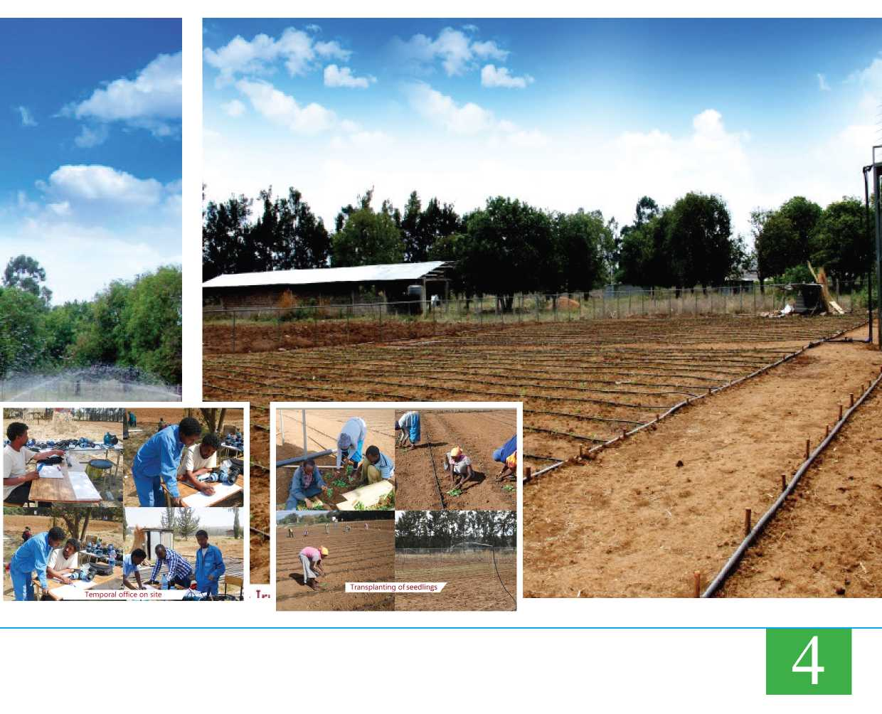

**HU Hosts International Conference on Applied Statistics in Agriculture**

**D**epartment of Statistics of Haramaya University hosted the first international conference on “Ap­plied Statistics in Agriculture” from 25-26 March, 2016. The conference addressed advancements and appli­cations of statistics in agricultural fields, drawing experi­ences from different countries.

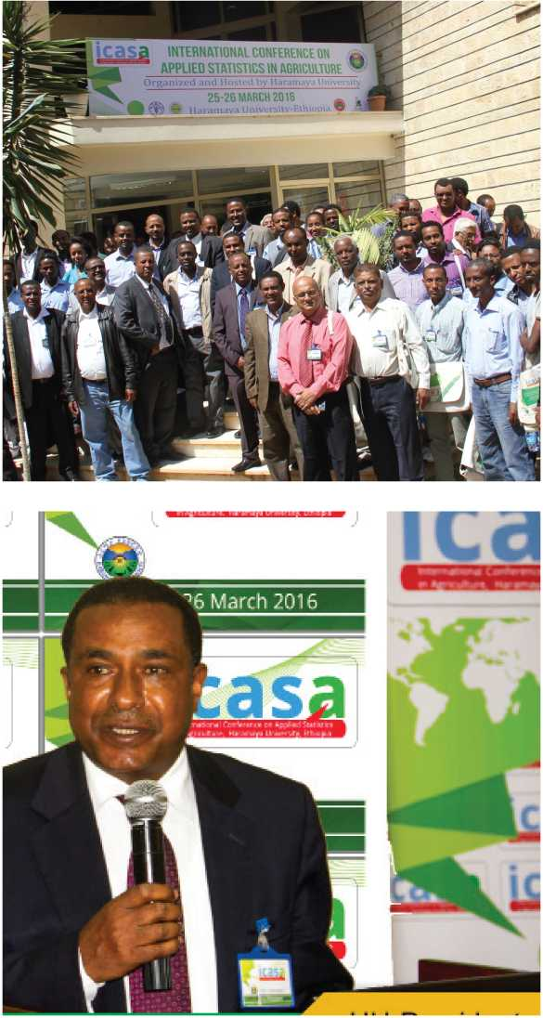

Ato Zena Habtewold from the Ministry of Agriculture and Natural Resources made an opening remark and addressed statistics’ role in the production and productivity in the ag­riculture sector. HU’s President, Professor Chemeda on his part also emphasized knowledge in statistics is a vital tool to possess. The interpretation of “different statistical meth­ods and models and how they would be better applied and used in agricultural research and surveys so that it helps the national endeavor of improving the productivity of crops, vegetable and fruits and livestock should be given empha­sis” Prof. Chemeda explained.

Guests included professors, researchers and academicians from different Ethiopian universities and from abroad. More than 20 articles were presented and discussion ses­sions were held. The conference saw more than 150 par­ticipants.

The conference was an important stage for researchers and aspiring young scientists to discuss about what has been done in the field of applied statistics in agriculture and what can be done for the future; new findings were also cited and discussed over.

In his closing remark, Professor Nigussie Dechassa, Vice­President of Academic Affairs, appreciated the successful completion of the conference and stated “it is also worth noting that a memorandum of understanding has been signed between HU and the Ethiopian Statistical Associa­tion (ESA) to jointly strengthen education and research in applied statistics and to disseminate new knowledge and innovation in the field.”

Ato Tariku Tessema, Statistics Department Head and Gen­eral Secretary of the conference organizing committee ex­pressed his sincere gratitude and appreciation to all who have strenuously participated in the wearisome organiza­tion of the successful completion of the conference

5

**Annual Research**

**r**

**(33rd**

**and Extension Review Workshop**

**HU Hosts National Workshop on Resilience and Vulnerability Reduc­tion on Moisture Stress Areas**

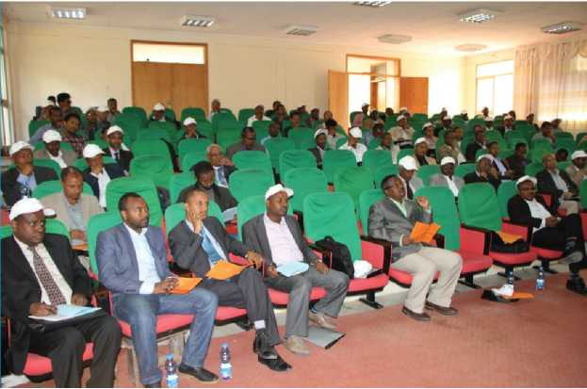

**A**nother major event that took place in Haramaya University (HU) was the national work­shop on ‘Building Scientific Resilience and Reducing Vulnerability in Moisture Stress Areas through Climate Smart Tech­nologies and Innovative Practices’ that was held at the University’s Re­source Center on January 14-15, 2016. The confer­ence was a collaborative work of HU and ZOA Relief]Hope|Recovery (an international non-govern­mental organization oper­ating in moisture stress ar­eas of Ethiopia). The NGO supports people who suf­fer because of armed con­flict or natural disasters, in helping them to rebuild their lives and livelihoods.

ZOA has been operating in Ethiopia since 1993 and currently has four programs in four regional states of the country.

HU’s president. Prof. Chemeda addressed the issues of food security, what is ex­pected of academic institutions regard­ing proposing science-based solutions toovercome problems of economic develop­ment and the University’s involvements and collaborations with governmental and nongovernmental organizations to ad­dress these problems.

Over twenty research papers were pre­sented to the attendees and discussion sessions were held. Topics of research pa­pers included ‘Effect of Iron Fertilization on Nodulation, Yield and Yield traits of Bradyrhizobium Inoculated Soya bean’, ‘Lessons from Watershed based Climate Smart Agricultural Practices in Jogo-gu- deto Watershed, Ethiopia’, ‘Assessmentof the effects of selected in-situ rainwa­ter harvesting techniques on soil moisture conservation in Fedis, eastern Hararghe, Ethiopia’, ‘Breeding Opportunities for Drought Tolerance and Production Chal­lenges of Cowpea (Vigna unguiculata L.) in Ethiopia’, ‘Disease Resistant and Drought Tolerant Wheat (Triticum aestivum L.)Varieties for Small Scale production in Eastern Ethiopia’, ‘Evalu­ation of Sequential Crop­ping System for Crop Di­versification of Different Crops in Fedis and Meiso, Eastern Ethiopia’, ‘Innova­tive Institutional Arrange­ments and Practices for Enhancing Resilience’, and ‘Climate Change Related Hazards, Early Warning In­dicators, and User Require­ments of Climate Forecast Information in Pastorial Areas of Ethiopia’.

Paper presenters and participants ranged from staff members and managerial per­sonnel from different colleges of the Uni­versity to other organization delegates and affiliates.

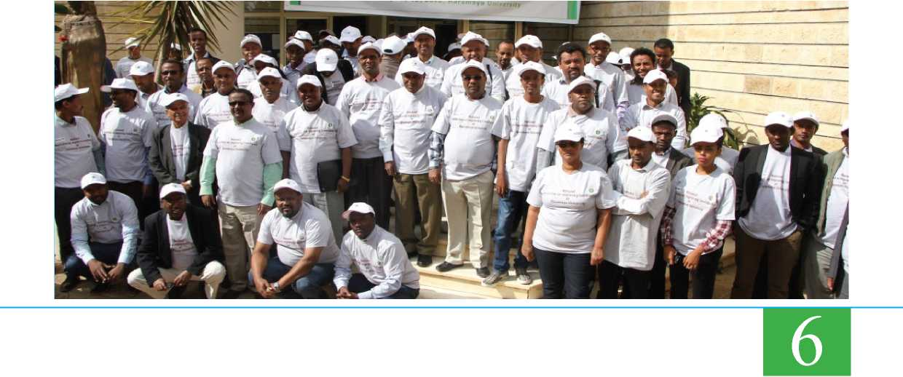

**Haramaya University and Dire Dawa University host 11th National TB Research Annual Conference**

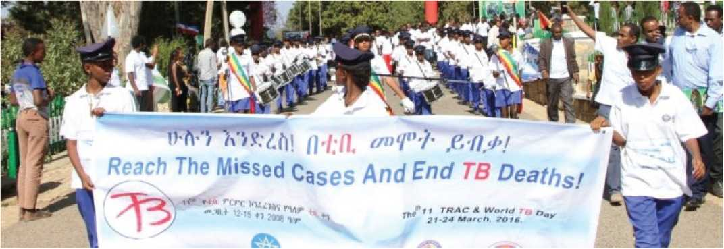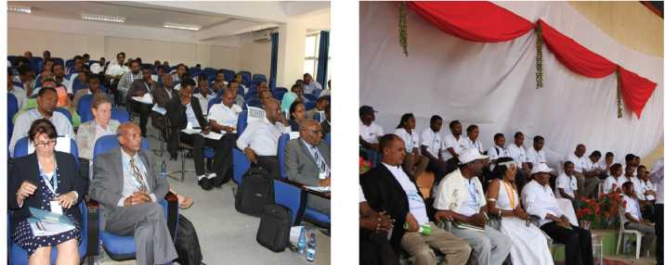

T

he National TB Research Annual Conference (TRAC) was success­fully conducted from March 21-24, 2016 with the theme of “Transforming TB response through Research and innova­tion” at Dire Dawa University.

Haramaya University’s President, Prof. Chemeda Fininsa, said that “HU has been working in different activities of the com­munity, particularly College of Health and Medical Sciences engages in training of undergraduate and postgraduate students in health fields and conduct research in TB.” The President urged the participants to work to reduce the burden TB imposes and make the environment more condu­cive.

FDRE State Minister of Health, Dr. Kebede Worku indicated that “We need to strive to transform TB intervention through research and innovations. Re­

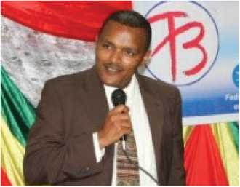

search papers that are to be conducted should advise stakeholders in the sector.”

A facilitated panel discussion on “Coun­try Adaptation of the End TB Strategy” was conducted and various scientific pa­pers have been presented and fruitful dis­cussions were held.

The conference is organized by Federal Ministry of Health, Dire Dawa Admin­istration Health Bureau, Dire Dawa Uni­versity and Haramaya University. It also brought together more than 300 advo­cates, researchers, health professionals and other stakeholders from all over the country and abroad.

In related news, HU colorfully celebrated the “World Tuberculosis (TB) day” on Wednesday 24 March, 2016 at HU Sport Academy.

The celebration was decorated by dif­ferent sport competitions between Dire Dawa City and Harari Regional cabinet members, and also between Dire Dawa University and Haramaya University staff. Finally the ceremony ended by awarding prizes for the winners in sport and other competitions.

On the occasion, Representative of Feder­al Ministry of Health, Dr. Ameha Fantaye, WHO-Country representative, Dr. Mutale Mumba and Athlete Derartu Tulu, Volun­teer Ambassador of TB campaign were in attendance.

7



**500 Movable Poultry Houses Produced and Transferred**

**H**aramaya University has supplied 500 one rack mobile poultry hous­es to ZOA in Midega Tola Wore- da in Eastern Oromia Regional State. A Memorandum of Understanding (MOU) was signed by the two parties on Febru­ary 2, 2016, to supply the poultry houses. ZOA, an international nonprofit organiza­tion is located in Jijiga in response to the alleviation of the recent drought that has affected the country.

The agreement has stipulated that ZOA would pay 1 million birr for the produc­tion and distribution of the poultry houses and HU is to provide the finished houses in a month and two week time. 20 em­ployees took part in the production of the houses. The University has a workspace inside the main campus were poultry house productions take place. HU is a leading university in the country striving to bring change to the farming community

with improved technologies; and has developed, produced and distributed thousands of poultry houses to farmers.

ZOA Relief| Hope| Recovery is implementing Dutch government funded project in Midega Tola Woreda in Eastern Oromia Regional State working to alleviate drought affected areas.

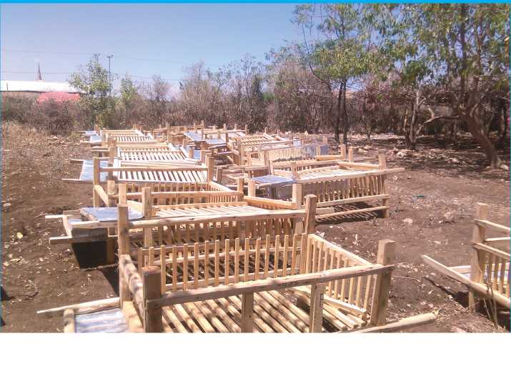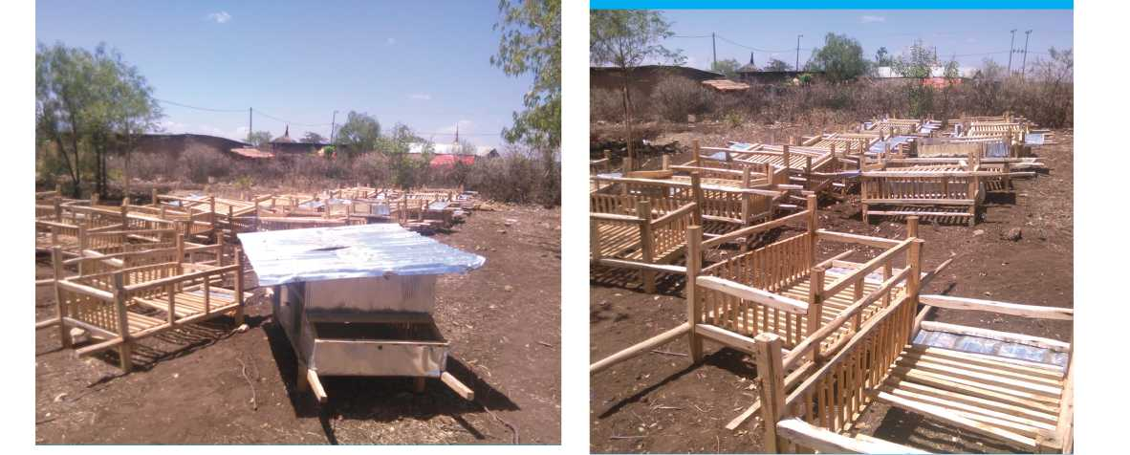

**and Extension Review Workshop**

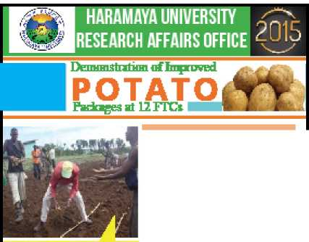

**Research and Extension Performance of HaramayaUniversity -2015**

-ararniiyn University has bean generating end promoting an proved potato technolo­gies ;eJ3L a GjdBneJithat havettve po:cn- tiBl yield up to 4.20 quintal ^hectare.

**l&emanst ratio ns of aatato technologies 'twe been made**\n **E districts atS Farmers' TYairarg Centers** fiFTCsj **[MBlfca-GcmBd-** j. **Efla-Drorniya.. Ba** B-.Bnge.. **Kftdo-'iftfatthi, Hara-Wnlipi** b, **A'gjg. GuOa-koricha|.**

**Awararess was created for 2-CC farmers through training, (demonstration, farmers' days.**

**Potato atsming at prope- spar­ing ard DAP tert' izer rate Farmers' knawledgs and skill 'released**

**ard fertile ground fur futher technology pinomotian *ras, establ'shed.**

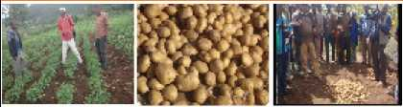

Potato **danmitritiiiifidd** visit **md** mfnatioii

through individual and **field diyfl**

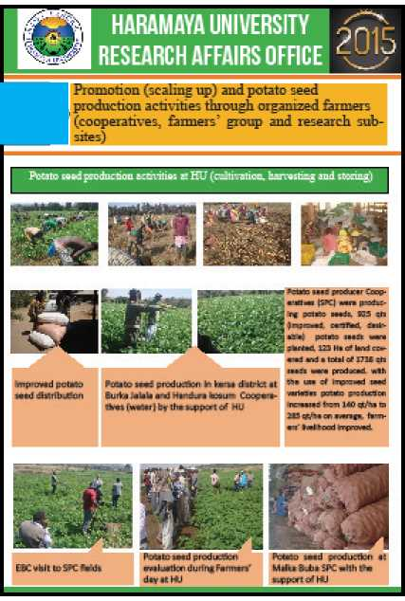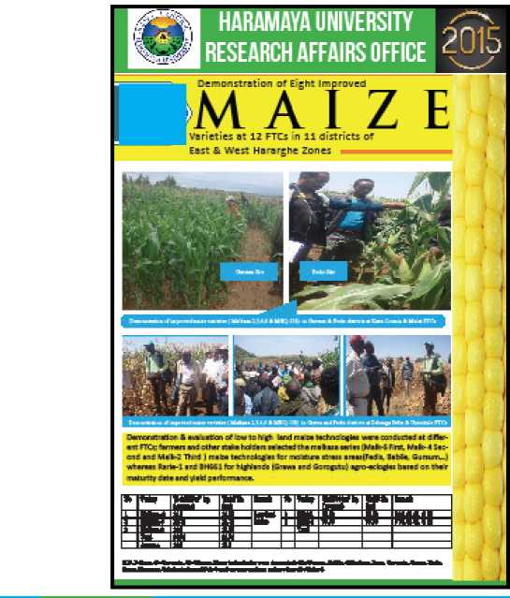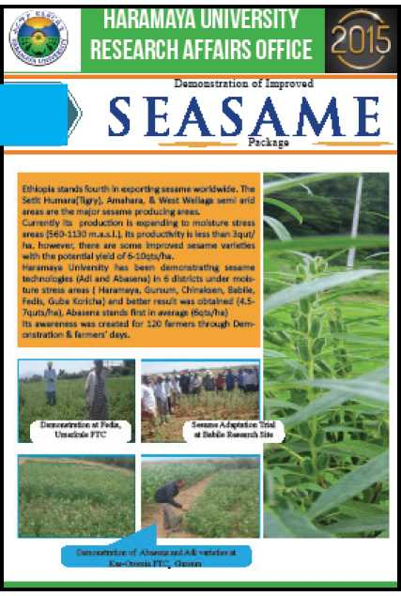

9



Annual Research



**and Extension Review Workshop**



**HARAMAYA UNIVERSITY  
RESEARCH AFFAIRS OFFICE**

2015

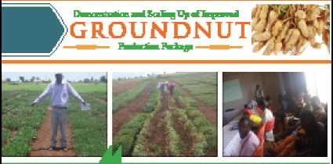

Demonstration at Babile and Gursum Reid Sites

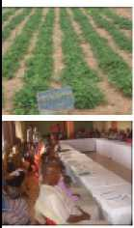

**Three Vnprawd growdnut techroog'es (Haha-Sjda. Eaha-Jidi. a*d Were_-962| were eeTianstrated at Ch - nntaen., Habile, Gtawi :edis and Hvama^n Guba- Korkfca riled sAsonsevefl FTCs.**

**nnvng** -abs **alsc gjren 'ar prarrotiar of these te:h- rinlogies.**

**These varieties are moisture stress tblerart ard art suitable for eastern part: of Ihe co jntry.**

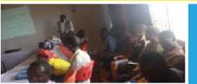

Training on groundnut scale-up far 30 DAs & expens gathered

from five gronndnur growing districts

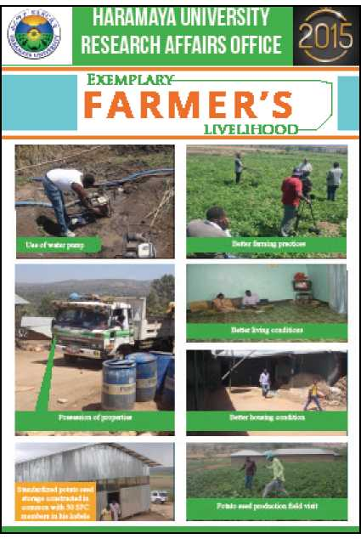

DflnunistnfHBi md ProanMioa of Two Higi.-yi6l.dLnn

**TOMATO**

T*c fcn ologwj



**HARAMAYA UNIVERSITY RESEARCH AFFAIRS OFFICE <UiJ**

Deme*3lrMknl ifld promotion a* Mo-iriia &

Shanty tomato technologic have bee- going

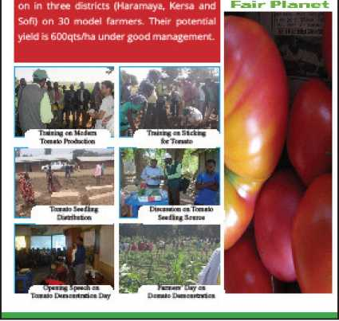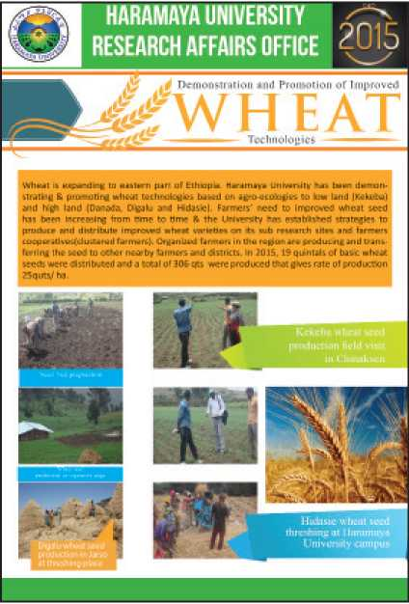

10

HARAMAYA UNIVERSITY RESEARCH AFFAIRS OFFICE 4U 9



Dtoi^n in-i Phnutim ni Two High-yic-LdLnH

**TOMATO**

DfrnertUralifrfl pmmtiEi&n uJ Ml-'inu & SharUy i.iji'Mlu EKJ"inclQf«* have bse* -g C«ri In ChcK dsHrkES (I Idr-Jivjyd, Kerw Jiid £*m LTI 30 TM.-dcl hHr Tit- i=. Their ucilif-'^idl yitclid-000qLLj'"j under gLod Twvi^enien^.

